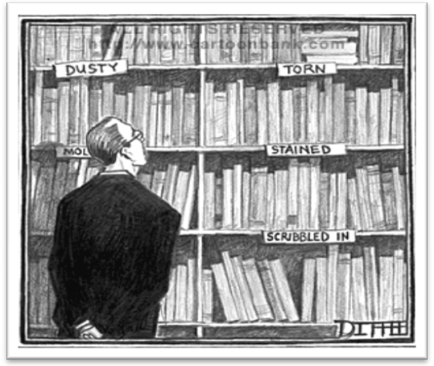

Matthew Diffee, The New Yorker

LIS 619 Preservation Management
Fall 2012 Syllabus
University of Hawai‘i at Mānoa

Instructor: Deborah Dunn
Contact numbers office: 956-2471 cell: 779-9046
Email: ddunn@hawaii.edu
Classroom: LIS 3F, unless otherwise indicated on syllabus
Class day/time: Tuesday, 5:00 – 7:40
Office hours Email for appointment

Course Description
An introduction to current practices, issues, and trends in the preservation of a variety of materials in libraries and archives, with an emphasis on integrating preservation ethics and practices throughout an institution's operations. The course is a composite of team and solo presentations, lectures, readings, guest stars who are leaders in the preservation field in Hawai‘i, written assignments and a final project.

Pre-Requisite: None

Student Learning Outcomes (SLOs) Addressed
SLO 1. Understand, apply and articulate the history, philosophy, principles and ethics of library and information science and the related professions.
1b) Demonstrate understanding of the historical context of information services and systems
1c) Develop and apply critical thinking skills in preparation for professional practice

SLO 2. Develop, administrate, assess, and advocate for information services by exercising principled communication, teamwork and leadership skills.
2b) Work effectively in teams
2c) Develop, manage, and assess information services for specific users and communities

SLO 3. Organize, create, archive, preserve, retrieve, manage, evaluate, and disseminate information resources in a variety of formats
3a) Demonstrate understanding of the processes by which information is created, evaluated, and disseminated
3d) Demonstrate understanding of issues and techniques of preservation of physical and digital objects

SLO 5. Engage in projects and assignments dealing with multicultural communities and representing diverse points of view
5b) Demonstrate understanding of the social and cultural context of information services and systems
5c) Apply LIS principles to meet the needs of Native Hawaiian and Asia-Pacific communities and to promote cultural sustainability

Professional Expectations
Students are expected to fully participate in every class and conduct themselves with integrity in all interactions with colleagues and the instructor. Please refer to the document, Professional Expectations Notice for LIS Graduate Students posted at: www.Hawaii.edu/slis/students/profexp.html.

Teaching Philosophy
It is the student’s responsibility to take steps to succeed in the coursework. I have structured the course to act as a springboard for group discussions and exploration in a shared learning environment. Every librarian, archivist and curator must have an understanding of basic preservation literature and theory. Awareness of preservation issues and some hands-on experience will work in your professional favor. Appropriate and consistent collections care will result in a positive impact on a library budget, increased access for users, and the stabilization of irreplaceable cultural and literary resources.

Assignments
Written assignments are to be handed in at the end of the class period on the due date. A brief explanation of each assignment follows; in-depth instructions will be covered in class.

Reading reporters (20 points)
Student pairs will be assigned to present and reflect on the issues raised in the weekly readings. Each presentation is allotted 40 minutes. Power point presentations are allowed, but other activities that engage the class in discussion are greatly encouraged. Various due dates.

Preservation Education Directives (15 points)
Create a product that informs an intended audience about preservation. Begin by choosing a target audience for your educational effort. For example, address the student in an academic library, a family in the public library, a genealogist in a county archives, an historian in a museum library, etc. Attract their attention and convince them to care about collections that they interact with. The product can be any size or media and should include key preservation points. The directives should be clear and palatable to the intended audience. Samples of student work from previous semesters will be shared. Students will share their assignments in class. Due October 23.

Two-minute lobbyist (15 points)
Students will each select an audience (legistative committee, governor, library donor, board of trustees, etc) of their choice and convince them to support a preservation and access initiative. Time limit is two minutes, with the possibility of follow-up questions. No Power Point allowed; this should be a well-practiced and delivered with confidence. Due November 13.

Fund development: project description (15 points)
Student pairs will select a preservation project and draft the project description, audience served, timetable and intended outcome. Due November 20.

Fund development: budget & budget narrative (10 points)
Student pairs will develop the budget, listing personnel, fringe, supplies, travel, equipment, consultants and more to achieve the results described in the project description. Due November 27.

Fund development executive summary (10 points)
All projects will be presented on December 4th, the last day of class, before handing in the full packet to instructor. Due December 4.

Attendance, class etiquette and participation (15 points)
• Attendance, preparation and participation is extremely important to the learning environment.
• Arrive on time; missing class without a valid excuse will affect the final grade, as will repeated lateness and leaving early.
• Turn off cell phones; absolutely no texting during class.
• Give speakers your full attention, avoiding private conversations while others are addressing the class.
• On field trips, follow the rules presented by the archivists and librarians at each location.

Grading
All written and oral presentations will be graded on both content and style.

For oral presentations, content and style relates to the organization, depth and accuracy of the material as well as the appropriate use of handouts and visual aids. Good grammar and clear pronunciation is important to the overall quality of the delivery.

With respect to written work, the grade will reflect the quality of the research, organization of the material, grammar, factual information, correct spelling, bibliographic citations and neat appearance. All written material should be typed using a 12 pt font and 1” margins with 1.5 spacing.

Late work: Assignments handed in late will have four points deducted each day (starting with the missed due day) for up to two days. Thereafter, no late papers will be accepted.
Grades are assigned upon a full semester’s completion of the coursework and will be determined by a combination of the points earned from assignments and activities listed above.
100-97 points = A+
96-93 points = A
92-89 points = A-
88-86 points = B+
85-82 points = B
81-79 points = B-
78-76 points = C+
75-72 points = C
71-69 points = C-
68-66 points = D+
65-62 points = D
61-59 points = D-

Readings
I have not required the purchase of a textbook. Information about Preservation Management comes from many good, reliable sources. I’ve selected some of the best and most provocative to introduce students to the literature. There will be several readings from Sherelyn Ogden’s book Preservation of Library & Archival Materials. The chapters can be read online or printed at the Northeast Document Conservation Center (NEDCC) website under Preservation Leaflets. http://www.nedcc.org/resources/leaflets.list.php

Other required readings are listed on the syllabus and links are provided when available. For Electronic Reserve readings (ER), go to Voyager and select Electronic Reserve under the instructor’s name and course title. For kokua see the guide at http://www.sinclair.hawaii.edu/help/tutorials/Electronicresources.html

Technology requirements

Use a computer to complete written assignments. Bring a laptop to the fundraising sessions 13-15, as we will begin drafting the assignments during class.

Helpful Websites
The Archival Products newsletter is specifically written for libraries, and published quarterly. The articles are written by preservation librarians and archivists. http://www.archival.com/newsletters/index.shtml

CoOL. A project of the Preservation Department of Stanford University Libraries and Academic Information
Resources, is a full text library of conservation information, covering a wide spectrum of topics of interest to
those involved with the conservation of library, archives and museum materials. http://palimpsest.stanford.edu/

The Library of Congress. See the Frequently Asked Questions section; a good introduction to preservation at LC.

http://www.loc.gov/preserv/presfaq.html

Northeast Document Conservation Center (NEDCC). Excellent preservation leaflets on the Environment, Planning and Prioritizing, Emergency Management, Storage and Handling, Care of Photographs, and Reformatting. http://www.nedcc.org/resources/leaflets.list.php

Image Permanance Institute (IPI). Created by the Rochester Institute of Technology in 1985, specializing in the preservation of photographs, from historic formats to digital collections. They have also led research in monitoring the environment, producing equipment and programs that accurately record data for the preservation librarian. Excellent posters! https://www.imagepermanenceinstitute.org/resources/publications

Over 4.8 billion artifacts are held in public trust by more than 30,000
archives, historical societies, libraries, museum, scientific research
collection, and archaeological repositories in the United States.

A Public Trust at Risk: The Heritage Health Index, IMLS, 2007

Session 1: August 21 | Focus | Readings | Assignments due
LIS 3F | Introduction to course  Defining preservation in library, archives and museum settings  Develop a Preservation Consciousness  Syllabus  Film: Slow Fires, On the Preservation of the Human Record, Council on Library and Information Resources, 1887  Prep for next week | No readings

Libraries and archives, where books, printed materials, manuscripts, maps, prints, photographs, and
various other materials are stored, perused, and exhibited, are not unlike the setting in agriculture where huge
quantities of foodstuffs are stored for long periods of time. The library setting is a concentration of foodstuffs,
including starches, cellulose, and proteins, which form a banquet for insects, rodents, and mold.

INTEGRATED PEST MANAGEMENT FOR LIBRARIES AND ARCHIVES
Thomas A. Parker, PhD

Session 2: August 28 | Focus | Readings | Assignment due
Meet at the benches outside of Sinclair Library, 5:00 | The Preservation Environment:  The building envelope and interior  Integrated Pest Management  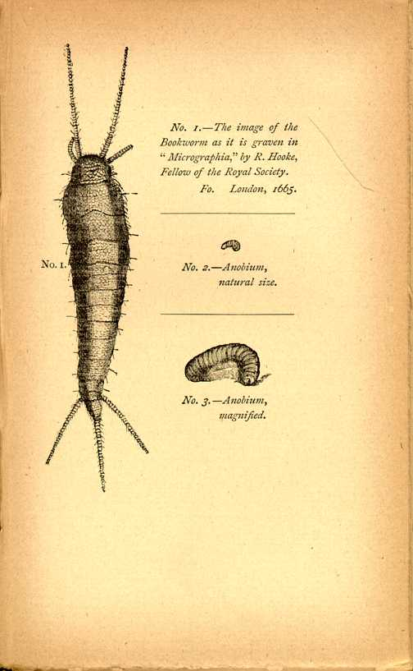  Housekeeping  Light, RH and Temperature,  Cooling systems | Ogden, Barclay, Collection Preservation in Library Building Design. LibrisDesign, 2004.  http://librisdesign.org/docs/CollectionPreservation.pdf  Nyberg, Sandra, “Invasion of the Giant Spore,” SOLINET Preservation leaflets, updated 2008.  http://cool.conservation-us.org/byauth/nyberg/spore.html  Blades, William, “Dust and Neglect.” The Enemies of Books, Chapter 4. Revised and Enlarged by the Author. Second edition. London: Elliot Stock, 1888. http://etext.virginia.edu/toc/modeng/public/BlaEnem.html  Waheneka Marjorie and Sherelyn Ogden, “Housekeeping,” Caring for American Indian Objects, A Practical and Cultural Guide, Minnesota Historical Society Press, 2004. pp. 62-68. ER  Dean, John F., “Preservation in Tropical Climates: An Overview,” International Preservation News, IFLA PAC, no. 54, pp 6-10. August 2011.  http://www.ifla.org/files/pac/ipn/IPN%2054def.pdf  Watson, Joyce, “Cleaning the Bookstacks After a Major Fumigation,” c. 1991.  http://www2.hawaii.edu/~adamson/vol43a2.html  Patkus, Beth Lindblom, “ Monitoring Temperature and Relative Humidity,” Preservation Leaflets 2.2, Environment, NEDCC website.  http://www.nedcc.org/resources/leaflets/2The_Environment/02TemperatureAndHumidity.php  Kim Klara’s Photostream. “Problem in the library.”  http://www.flickr.com/photos/klara/170057515/

Some currents of our inner ocean
Follow the first hand that set them moving.
(“Wear” in Green Man, 1999)
John Donlan, poet and librarian

The Old Man is suspicious right from the start. He fears that his traditional, indigenous communication space has been usurped by a mere machine….Children sit around the radio set to hear stories from people whom they do not know, and who may not necessarily wield the same respect as the traditional communicators living in the community….He was worried about the birth of a new type of silence in which the children were reduced to mere recipients of messages or information without being participants. (Zimbabwe)
Chenjerai Hove
The Place of Oral Traditions in Indigenous Communications

Session 3:  Sept 3 | Focus | Readings | Assignment due
LIS 3F | Indigenous and non-Western materials in libraries, archives and museums  Moving collections & protective housing | First Archivists Circle, “Protocols for Native American Archival Materials,” 2007  http://www2.nau.edu/libnap-p/protocols.html  UNESCO Memory of the World,"Memory of Asia"  Project to preserve palm-leaf manuscripts of Asia,  http://xlweb.com/heritage/asian/palmleaf.htm  Dawrs, Stu, “Pele’s PhD,” Hana Hou, Vol 12.no.6, 2010.  http://www.hanahou.com/pages/magazine.asp?Action=DrawArticle&ArticleID=837&MagazineID=30&Page=1  Firth, Niall, “Tablet PCs preserve indigenous knowledge  New Scientist,” 18 June 2012.  http://www.newscientist.com/article/mg21428696.400-tablet-pcs-preserve-indigenous-knowledge.html  Secrets of the Cave I: “Sacred Waste,” early Tibet.com,  http://earlytibet.com/2010/12/13/secrets-of-the-cave-i/  Secrets of the Cave II: The “Library Cave,” earlyTibet.com,  http://earlytibet.com/2011/03/11/secrets-of-the-cave-ii/  Chinese bookbinding - the International Dunhuang Project  http://idp.bl.uk/education/bookbinding/bookbinding.a4d  Guidelines for handling and moving your special objects, ICON Institute of Conservation.  http://www.conservationregister.com/PIcon-Handling.asp  Recommended reading  Burtis, Amber, “Managing Indigenous Knowledge and Cultural Traditions; Is Technology The Solution?”  http://www.libr.org/isc/issues/ISC29/articles/3%20-%20Managing%20Indigenous%20Knowledge.pdf | Reading reporters:

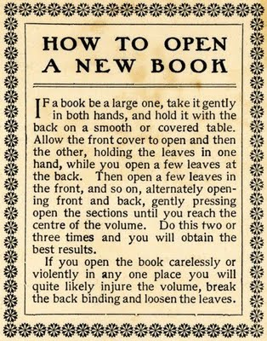

Session 4:  Sept 11 | Focus | Readings | Assignments
LIS 3F | Know your collections: Paper & books  Part I  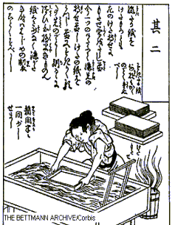  Library binding  Circulating materials  Medium rare books  Hands-on: Basic repairs | Song Yingxing, “Bark Paper,” Exploitation of the Works of Nature, Chap. 13, Papermaking, China, 1637. http://www.rice-paper.com/about/production/songyingxing.html  Maravilla, Mimfa R., “Causes of Deterioration of Paper.”  http://cool.conservation-us.org/byauth/maravilla/deterioration-causes.html  Elmer Eusman, “Iron Gall Ink,” The Ink Corrosion Website, http://www.knaw.nl/ecpa/ink/ink.html  Library of Congress, Saving the Written Word:  Mass Deacidification at the Library of Congress, 2006.  http://www.loc.gov/preserv/deacid/massdeac.html  Publisher’s Bindings Online, 1815-1930: The Art of Books http://bindings.lib.ua.edu/  Eye on the Government Printing Office  http://www.youtube.com/watch?v=XkYVRVmbIAk  University of Delaware Library, “Guide to Identifying Damaged Books,” Preservation Department, 2009.  http://www2.lib.udel.edu/Preservation/damage_id/identifying_damage.htm | Reading reporters: How relevant is Slow Fires today? Give us an update --

As the broadest and most reliable systematization of contemporary knowledge that had yet appeared, Diderot's encyclopedia achieved a tremendous popularity among the literate, so much so that it provoked the King's Council in 1759, to suppress the first seven volumes, and forbid further publication. Diderot had already undergone persecution through suspensions of printing and threats of imprisonment, but he continued to work on the ten remaining volumes. At the last moment came the bitterest trial of all, the publisher had mutilated these volumes by suppressing whatever might be offensive.
Diderot's Encyclopedia
Historical Text Archive

It is no wonder that Callimachus, a professional cataloguer of books from
Alexandria's library, said "a big book is a big nuisance."

Session 5:  Sept 18 | Focus | Readings | Assignment due
Meet in Gov Docs, Ground floor, Hamilton | Know your materials: Paper & books II  Guest star: Mabel Suzuki, map librarian  Special Collections  What makes a book rare?  Oversized & undersized collections  Handling and storage | “The Birth of Printing, Gutenburg to Gates, 500 Years of Books, from Printing Press to Computer,” 2000. Virtual exhibit http://www.springfieldlibrary.org/gutenberg/print.html  Houghton Library, “Guidelines for Handling Manuscript Materials,” Handling Special Collections, Harvard University website.  http://hcl.harvard.edu/libraries/houghton/assistance/handling_special_coll.cfm#manuscript  Treasures of Timbuktu-Mali.  http://www.youtube.com/watch?v=5TFbEks_zFc&feature=related  Ford Foundation, Timbuktu: Recapturing the Wisdom and History of a Region  http://www.youtube.com/watch?v=_vKBcJsqmOA&feature=related  Rutgers University Libraries, “Proper Shelving for Standard and Oversize Collections”, Collection Management Group, 2008. http://www.libraries.rutgers.edu/rul/staff/access_serv/coll_mgt/shelving_oversized.pdf  “Protecting Books with Custom-Fitted Boxes,” Preservation Leaflet, Storage and Handling 4.5, NEDCC. http://www.nedcc.org/resources/leaflets/4Storage_and_Handling/05ProtectingBooks.php | Reading reporters:

Move over, kangaroo rats, spotted owls, and shortnose sturgeons.
The floppy disk is about to join you on the endangered species list.
Farewell, My Floppy
PC World, 2003

Session 6:  Sept 25 | Focus | Readings | Assignment due
Meet in Preservation Department, Room 552 | Reformatting  Guest star: Christine Takata, Preservation reformatting and digital lab supervisor, Hamilton Library  Tour of Preservation Department | Dalton, Steve, “Microfilm and Microfiche.” Conservation of Library and Archival Materials, Reformatting section 6.1. Edited by Sherelyn Ogden. Andover, MA: Northeast Document Conservation Center.  http://www.nedcc.org/resources/leaflets/6Reformatting/01Microfilm  Gertz, Janet, “Preservation and Selection for Digitization,” Revised 2007, Conservation of Library and Archives. Edited by Sherelyn Ogden, Andover, Massachusetts: Northeast Document Conservation Center, 2008. http://www.nedcc.org/resources/leaflets/6Reformatting/06PreservationAndSelection.php  Conway, Paul, “The Relevance of Preservation in a Digital World.” Conservation of Library and Archives. Edited by Sherelyn Ogden, Reformatting section 6.4. Andover, MA: Northeast Document Conservation Center. 2008. http://www.nedcc.org/resources/leaflets/6Reformatting/04RelevanceOfPreservation.php  AIA, adapted from a Practice Management Digest article by Alison Langmead, “Long-term Preservation of Architectural Records,” August 2007.  http://www.aia.org/aiaucmp/groups/ek_members/documents/pdf/aiap027032.pdf  Baker, Nicholson. “Destroying to Preserve,” Double Fold, Libraries and the Assault on Paper, Chap. 3: 22-26. New York: Random House, 2001. ER | Reading reporters:

Session 7:  Oct 2 | Focus | Readings | Assignment due
Sinclair Library, 3rd floor, near Wong AV | Audio visual collections  Video and sound recordings  Guest star: Jim Hearon, Media Specialist, Sinclair Library  Photographs  Scrapbooks | Library of Congress, “Cylinder, disc and tape care in a nutshell,” Website.  http://www.loc.gov/preservation/care/record.html  American Institute for Conservation of Historic and Artistic Works, “Caring for your Home Videotape.” http://aic.stanford.edu/library/online/brochures/video.html  National Preservation Office, “Caring for CDs and DVDs,” July 2008. http://www.bl.uk/blpac/pdf/cd.pdf  Bromberg,Nicolette, Hannah Palin with Libby Burke, Washington State Film Preservation manual,  http://www.lib.washington.edu/specialcoll/film/preservationmanual.pdf  Albright, Gary, “Storage Enclosures for Photographic Materials” Preservation Leaflets, Storage and Handling, 4.11, NEDCC.  http://www.nedcc.org/resources/leaflets/4Storage_and_Handling/11StorageEnclosures.php  Library of Congress, “Preservation Basics: Preservation of Scrapbooks and Albums,” Collections Care.  http://www.loc.gov/preservation/care/scrapbk.html | Reading reporters:

The most difficult challenge for libraries is deciding how to set priorities for preservation.
As long as the claim on preservation resources exceeds the available funds, it will be
necessary to select which materials will get treatment and which will not.

The Evidence in Hand: Report by the Task Force on the Artifact in Library Collections,
Council on Library and Information Resources. Washington, D.C. 2001

Session 8:  Oct 9 | Focus | Readings | Assignment due
LIS 3F | Planning and Policy-making  Selection for preservation  Access policies | American Library Association, Preservation Policy 2008.  http://www.ala.org/alcts/resources/preserv/08alaprespolicy  Northeast Document Conservation Center. Preservation Planning: Guidelines for Writing a Long Range Plan. Edited by Sherely Ogden. Andover, Washington, D.C.: American Association of Museums, 1997.  Ogden, Sherelyn, “What is Preservation Planning?” Technical leaflet 1.1, Preservation of Library and Archival Materials: A Manual, Third Edition, Revised and Expanded, Sherelyn Ogden, ed.. Andover, MA: Northeast Document Conservation Center, 1999.  http://www.nedcc.org/resources/leaflets/1Planning_and_Prioritizing/01WhatIsPreservationPlanning.php  Ogden, Sherelyn, “Priority Actions for Preservation,” Technical leaflet 1.6, Preservation of Library and Archival Materials: A Manual, Third Edition, Revised and Expanded, Sherelyn Ogden, ed.. Andover, MA: Northeast Document Conservation Center, 1999.  http://www.nedcc.org/resources/leaflets/1Planning_and_Prioritizing/06PriorityActions.php | Reading reporters:

Session 9:  Oct 16 | Focus | Readings | Assignment due
LIS 3F | Building a preservation program  Staff & patron education  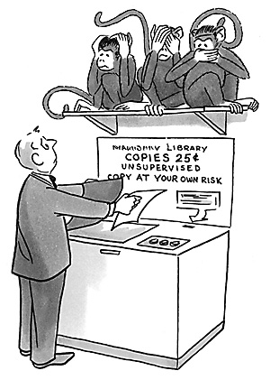 | DiConsiglio, John, Connecting to Collections: A Report to the Nation, Institute of Museum the Library Services, Washington DC, 2010. www.imls.gov/collections/  UCSD Libraries, “Mutilation of Library Materials,”  http://libraries.ucsd.edu/preservation/mutilate.html  Baird, Bryan J., “Preservation Strategies for Small and Public Libraries,” Archival News, Vol. 7, no. 2 (Summer 1999): 1-4. http://www.archival.com/newsletters/apnewsvol7no2.pdf  Waters, Peter, “Phased Conservation,” in The Book and Paper Group Annual, The American Institute for Conservation. Vol. 17, 1998. http://aic.stanford.edu/sg/bpg/annual/v17bp17-17.html  Oxford University Library Services, “Handling Library Material,” Conservation and Collection Care, Bodlien Library.  http://www.bodley.ox.ac.uk/dept/preservation/training/handling/bookmarks.htm  Library of Congress. Preservation Photocopying.  http://www.loc.gov/preserv/care/photocpy.htm l  University of Washington Libraries, “Food, Drink and Tobacco Policy.”  http://www.lib.washington.edu/preservation/foodbev/foodpol.html  McQueen, Mike, “FREE PANCAKES IN THE LIBRARY! We do it and so can you!” Getting Boys to Read.com.  http://www.gettingboystoread.com/content/free-pancakes-library-we-do-it-and-so-can-you | Reading reporters:

Session 10  Oct 23 | Focus | Readings | Assignment due
LIS 3F | Risk Management  Security  Disaster planning  & Response | Brown, Karen and Beth Lindblom Patkus, “Collections Security: Planning and Prevention for Libraries and Archives.” Preservation of Library and Archival Materials, Emergency Management Section 3:11. NEDCC website, 2008.  http://www.nedcc.org/resources/leaflets/3Emergency_Management/11CollectionsSecurity.php  The Hardford, “Preventing Fires In Library Books Returns,” Loss Control Tips, Technical Information Paper Series, 2002. http://www.thehartford.com/corporate/losscontrol/TIPS/680-350.pdf  Harvey, Miles, 2000, “The Invisible Crime Spree.” The Island of Lost Maps, A True Story of Cartographic Crime,. New York: Random House, 2000. Chapter 6:107-133. ER  Motylewski, Karen, “Protecting Collections During Renovation,” Preservation leaflets, Emergency Management 3.9. NEDCC website. http://www.nedcc.org/resources/leaflets/3Emergency_Management/09ProtectingCollections.php  Patkus, Beth Lindblom, “Disaster Planning.” Preservation of Library and Archival Materials, Emergency Management Section 3:3. Edited by Sherelyn Ogden. Andover, MA: Northeast Document Conservation Center, NEDCC website, 2008.  http://www.nedcc.org/resources/leaflets/3Emergency_Management/03DisasterPlanning.php  Patkus, Beth Lindblom, “Emergency Salvage of Moldy Books and Paper.” Preservation of Library and Archival Materials. Emergency Management Section 3.8. Edited by Sherelyn Ogden Andover, MA: Northeast Document Conservation Center. NEDCC website, 2008.  http://www.nedcc.org/resources/leaflets/3Emergency_Management/08SalvageMoldyBooks.php  Thenell, Jan, “After the Crisis, A Time of Opportunity,” The Library’s Crisis Communications Planner, A PR Guide for Handling Every Emergency. Chap. 9: 60-66. Chicago: American Library Association, 2004. ER | Presentation of Education directives  Reading reporters:

Session 11:  Oct 30 | Focus | Readings | Assignment due
LIS 3F | Exhibitions  Loans  Packing & Shipping  Working with conservators  NO CLASS NEXT WEEK | Glaser, Mary Todd, “Protecting Paper and Book Collections During Exhibitions.” Preservation of Library and Archival Materials. The Environment section 2.5. Edited by. Sherelyn Ogden. updated 2007. http://www.nedcc.org/resources/leaflets/2The_Environment/05ProtectingCollections.php  Northeast Document Conservation Center, “How to Do Your Own Matting and Hinging,” Conservation Procedures, Preservation Leaflet 7.4.  http://www.nedcc.org/resources/leaflets/7Conservation_Procedures/04MattingAndHinging.php  Registrars Committee, “Standard Facilities Report-United States,” American Association of Museums, 1998.  http://sceti.library.upenn.edu/dreyfus/docs/Standard_Facility_Report.pdf  American Institute for Conservation, How To Choose A Conservator. Website. http://www.conservation-us.org/index.cfm?fuseaction=Page.viewPage&pageId=1345  Browse these online exhibitions  National Library of Medicine, National Institutes of Medicine, Native Voices, online exhibition.  http://www.nlm.nih.gov/nativevoices/  University of Otago, NZ, Pulp Fiction Exhibition, Special Collections, online exhibition. http://www.library.otago.ac.nz/exhibitions/pulp_fiction/  The Morgan Library and Museum. Written in Stone, Historic Inscriptions from the Ancient Near East, ca. 2500 B.C.–550 B.C., Online exhibitions. http://www.themorgan.org/collections/works/WrittenInStone/default.asp | Reading reporters:

You must be prepared to give people a reason for investing in Collections
care. The pressing needs in your institution may be obvious to you, but they
won’t be apparent to prospective donors without a clear message
that people remember and want to act on.

A Memorable Message Wins Committment
Capitalize on Collections Care, NIC

Session 12:  Nov 13 | Focus | Readings | Assignment due
LIS 3F | Fund development 1: Project narrative  Guest star: Stuart Ching, archivist, museum curator and fundraiser | Heritage Preservation in partnership of The Institute of Museum and Library Services, Heritage Health Index and Capitalize on Collections Care, The National Institute for Conservation. http://www.heritagepreservation.org/PDFS/Capitalize.pdf  Carter, J. Drusilla, How to Write a Grant Proposal. http://www.libsci.sc.edu/bob/class/clis724/SpecialLibrariesHandbook/HowtoWriteaGrant.pdf  National Endowment for the Humanities, online Application Packet, Division of Preservation and Access,  http://www.neh.gov/files/grants/pa-research-development-may-16-2012.pdf  Institute of Museum and Library Services, Native Hawaiian Library Services -- FY 2011 Guidelines, website  http://www.imls.gov/applicants/guidelines/pdf/FY11_NAG-Hawaiian_Guidelines.pdf  Top Giving Foundations: Hawaii, The Grantsmanship Center http://www.tgci.com/funding/top.asp?statename=Hawaii&statecode=HI | Two-minute lobbyists

Session 13:  Nov 20 | Focus | Readings | Assignment due
LIS 3F | Fund development 2: Budget and budget narrative | National Endowment for the Arts, "Tips" for Writing Successful Proposals, sec. 4.7.  http://www.umass.edu/research/system/files/NEA-proposal_tips.pdf  [Samples of successful proposals], Conservation Project Support, Institute of Museum and Library Services, 2011.  http://www.imls.gov/assets/1/AssetManager/CPS_Samples_FY12.pdf | Project description, audience benefit, timeline, proposed outcomes

Session 14:  Nov 27 | Focus | Readings | Assignment due
LIS 3F | Fund development 3: Writing the executive summary  Careers in the Preservation field | Doyle, Beth, “Careers in Preservation Librarianship,” LIScareer.com, Career Strategies for Librarians  http://www.liscareer.com/doyle_preservation.htm  Campbell Center, Collections Care Core Curriculum  http://www.campbellcenter.org/pages/collections.html  Rare Book School http://www.rarebookschool.org/courses/  Martinez, Jennifer, “Beginning Book Conservation,” AIC, Emerging Conservation Professionals Network, 2011. http://emergingconservator.blogspot.com/2011/01/beginning-book-conservation.html | Turn in project budget and budget narrative

Session 15:  Dec 4 | Focus | Readings | Assignment due
LIS 3F | Course review  Ua Pau! | No readings | Present Executive summaries  Turn in edited proposal packet

