Session 1: Introduction to HTML

Objectives
The overall objective of the LIS Web Team HTML Workshop series is that you will be able to create, upload, and maintain your own websites using basic HTML code.

The main goal of this first session is that you will know the key vocabulary and concepts underlying the Internet structure and web page creation. By the end of the class you will have an actual web page and a handy list of useful resources.

Part 1

INTERNET and HYPERTEXT MARKUP LANGUAGE

What is the Internet?

The Internet
“Internet” comes from the inter-communication or inter-connection of various “computer networks.”

Computer network
A computer network is a number of computers that can communicate with each other, for example through telephone wires or wireless radio waves. Each computer has a unique address that distinguishes it from all other computers on that network, and this is how the computers communicate with each other. In turn, the computers in that network share a common address that separates them from other networks. Each network might belong to a larger network, and that larger network might belong to an even larger one.

The Internet is simply a worldwide network of networks that are connected with each other.
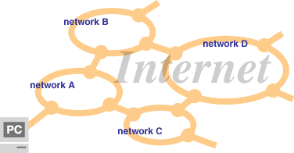

Functions of the Internet
  - WWW (World Wide Web)
  - E-mail
  - Net News
  - Chat
  - FTP (File Transfer Protocol)

By connecting your computer to the Internet, you can browse websites that exist in any network of this worldwide network. Creating your web pages and making them public means to put them on the network of the Internet.

How are Web pages created and how do they work?

The Web (World Wide Web or WWW)
The Web is the system that “web pages” are built upon.
In the early 1990’s, Tim Berners-Lee, a physicist at the CERN laboratory in Switzerland, created the web. His text-based web (composed of documents, files, and programs) was capable of understanding the various formats (protocols) traveling the network. The world quickly caught on and it became known as the World Wide Web or WWW. In 1993, Marc Anderson created Mosaic, a graphical web browser. Later other formats such as sound, photos, and video came on the scene.

Web Pages
A web page is an electronic document…containing text, maybe pictures, it can even have animation and sound. Although a webpage may look like it is one file it is usually made of separate files: text files, image files, audio files, video files. The glue that holds all these files together is called a markup language. The most popular tool to help you do this is “HTML (Hypertext Markup Language).”

Web sites (websites)

Websites are collections of web pages. The first or main page in a website is called home page. The sub pages link from this page.

HTML (Hypertext Markup Language)
HTML is the basic programming language used for creating web pages. It is formed from the two parts: tags and data. Hypertext is a document that enables to jump to other parts or pages by clicking.

Hyperlinks (Links)
Hyperlinks “are clickable text or graphics that enable you to access additional Internet resources.” Also known as links. Most web pages use hyperlinks to other web pages.

Browsers (Internet browsers)
Browsers are software your computer uses to view web pages created by various programming languages including HTML. Well-known browsers include Netscape Navigator, Internet Explorer, Firefox and Safari.

As you create your web pages, it is important to “test” them in different browsers. Your page may not look the same. Be aware that versions of the same browser from the same software company may differ from each other as well. For example, earlier versions of Internet Explorer cannot do things that the latest version is able to do.

How can web pages be put on the Web?

Web Servers

Web servers are computers that house one or more Web sites. When a browser on a PC asks to view a web page from over the network, the server is responsible for sending the page to the requesting PC.

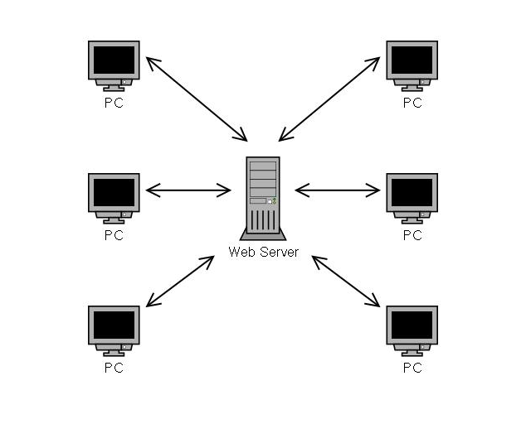
UH has its own servers and you can connect to them through the Internet. You can also create your own website on the UH server. If you have a UH email account your also have a place reserved on the UH web server for your own personal website.

The UH system’s servers use an operating system that is different from Windows or Mac. It is called UNIX. The computer you may be using could be a Windows or Mac computer, but it can still communicate with a UNIX server because of “protocols.”

Protocols
Protocols are a set of rules that have been agreed upon that determine how data should be transmitted. The web uses “HTTP protocol” to transmit HTML documents.

So that computers can talk to each other we have protocols, that is why you can use a Windows or Mac computer (as a client) to talk with a UNIX machine (the server). There are many types of protocols and they provide many useful services for reading, editing and writing information on the web. The protocols are used in various software.

Another important protocol is “FTP”, which is used to transfer HTML files or images to the web severs.

URL (Uniform Resource Locator)
an Internet address that tells your web browser where to look on the Internet (which network or server) to find a specific web page.

http://www2.hawaii.edu/~yokokudo/index.htm.
www2.hawaii.edu
~yokokudo
index.htm
a. b. c. d.

a. Protocol.
b. Domain name (server name)
c. Directory name (the space reserved for you)
d. File name

When you enter this URL on a browser, the browser will
connect to the server named “www2.hawaii.edu” by
the “http” protocol, and find a file named “index. htm”
in the “~yokokudo” directory.
*You do not need to enter “index.htm.”- The browser will
recognize it as “index.htm” when you do not type in a file name.

Your Homepage

The following are the steps for creating your personal homepage or index.html page on the UH server.

To establish your space on the UH server and create a home page:

- Go to http://www.hawaii.edu/account/
- Sign in with your UH username and password.
- Under “Personal Home Page Options” click on the link “Create Homepage.”
- Put in a title, choose a logo, and type in some text in the comment box. Press continue. Write down your home page URL address (e.g. http://www2.hawaii.edu/~yourusername).
- Open a new browser window. Type in the address of your new homepage.
- Once you make your homepage, the address will be http://www2.hawaii.edu/~your username. Notice that index.html is not added to the end of the address, but rather it is implied.

Uploading/Downloading with SSH Secure File Transfer Client
Now that you have set up your homepage, let’s take a look at the actual file structure of you site, and the index.html file that will be your main file for these sessions.
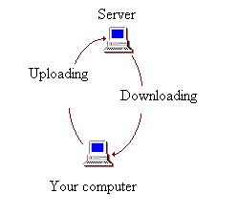
(1) Find “SSH Secure File Transfer Client” either on the desktop or in the “programs” menu and start the program. (If you need this software on your computer, you can download it for free from UH at http://www.hawaii.edu/help/software/supported.html - for Mac computers, you should use “Fugu” which is the same kind of program.)

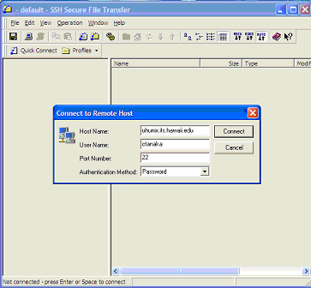
(2) Click on the QUICK CONNECT icon. You will get a box into which you can type the name of the uhunix server and your account or login name. The “Host Name” is uhunix2.its.hawaii.edu; the “user name” is your UH username.

Click CONNECT when you are done.
You will then get a box asking for your password. Type in your password and click OK.

If you get a message telling you that this is the first time you are requesting an encrypted connection with the server and whether it is ok to save a host key to your local database, go ahead and click YES.

(3) Now you should see folders on the left and right of the screen. Those on the left are on the computer, those on the right are on the server (live on the internet!).

(4) Find the folder that says public_html. Anything in this folder is visible to the public as web pages – all your webpages will go in here from now on. Double-click on public_html.
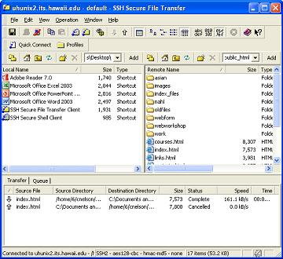
(5) Find the file named “index.html” This is your homepage! Homepages (the very first page for your website) are almost always named index.html – this is the default name that the browser looks for when it starts to load your site. Now, look on the left side of the program – find the folder on your computer that you want to store your web files in, and open that folder. Click and hold on index.html, drag it over to the left side of SSH, and drop it into the folder you want.

You should see lines of text in the bottom-most area – those lines are showing you that your file is downloading, and where it went to. When the line says “complete,” your download is finished!

CONGRATULATIONS! You have now downloaded your index.html file. In order to
upload it, you would simply drag the file from the left side, back to the right side again.
Setting Permissions
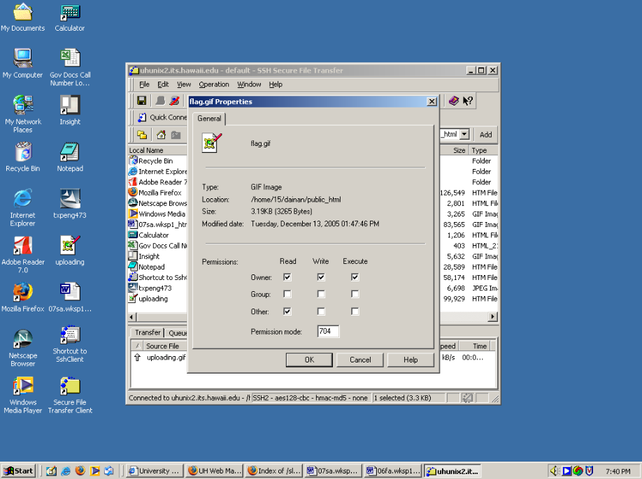Once the file has been placed on the server and into the appropriate folder, the permissions can be changed allowing you to store the file on the server where no one can see it, or making available for all to see. To set the permissions, right-click the file. A small menu will appear with “Properties” on the bottom. Open the properties and at the bottom you will see a set of boxes under the heading “Permissions.”

By clicking on the boxes, you can make the file readable, writable, or executable to the owner (yourself), a group (like if you were in an office network, and it were your whole department), or others (meaning the entire internet-viewing public, anywhere in the world!). Generally, you want to ensure that you, the creator, have full access by check marking all three options for owner. To make it viewable to everyone else, check mark the “Read” box under “Other.”

Part II: PLANNING A WEBSITE

The Heart of Your Web Page
Studies show that visitors spend less than 30 seconds checking out your web page. In fact, according to expert Jakob Nielsen, author of Designing Web Usability (2000), “it is almost twice as common for users to fixate on the text as on the images upon their initial visit to a page. In general, users were first drawn to headlines, article summaries, and captions.” Apparently, the web reading habits are “non-linear” and involve much more scanning for bits of info. Clarity in this format is everything, much like a newspaper article.

Although designing your web page can sound much more exciting than playing with the text, it is best to get a handle on your content first. Like a news writer, you want to answer the Who, What, Where, When questions as quickly as possible.

Millhollon and Castrina’s Web Writing Checklist (pp. 33 & 34)
❑ One idea per paragraph.
❑ Short sentences without dumbing down. Avoid compound sentences.
❑ Think about adding attractive visual highlights to your words.
❑ Use bullets whenever possible.
❑ Insert headings and subheadings to break up and highlight key text.
❑ Keep headlines simple and direct. Meaningful words preferred over clever ones.
❑ Follow a logical system of subordination. (e.g. main headings larger than the subheadings).
❑ Separate paragraphs with white spaces.
❑ Avoid too many hyperlinks on one page.

Let’s Look at Some Web Pages
Queen’s Borough Public Library, http://www.queenslibrary.org/
Glen Eira Library & Information Service, http://www.gleneira.vic.gov.au/library/
Rudy’s Alaska Fishing Page, http://www.alaska.net/~guidesak/rudy/rt.htm
The Bus: Oahu transit services, http://www.thebus.org/

Brainstorming
- Jot down every concept you want in your website or web page.
- Make sure you have a print copy of your ideas and write down the keywords next to each topic.
- Look over the keywords. Which ones should be headings and which ones should be hyperlinks?

Copyright and the Web
- Life plus 70 years (USA).
- Protects words used, not the idea itself.
- Paraphrase & reference (can provide a link).
- Be careful for the use of copyrighted images- Follow terms and conditions provided.

Key HTML Techniques for Web Page Design

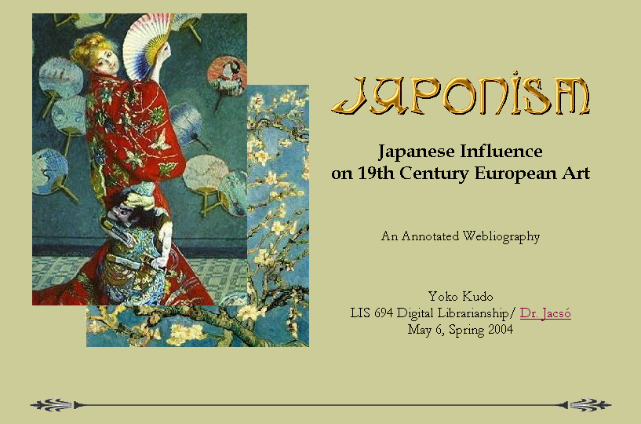
Identify images you want to use for your site
Decide what topics or sections you will have
Think about the color scheme you want for your text and background

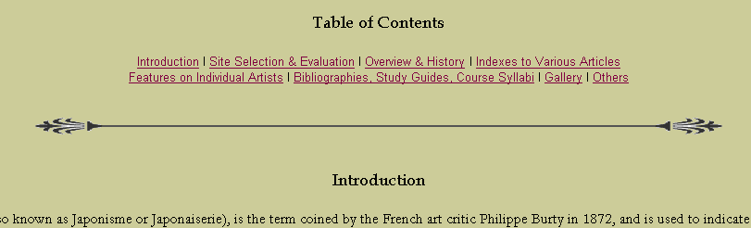
We will learn how to center texts, how to make them bold, and more!
We will learn how to make links!

References

Millhollon, Mary, and Jeff Castrina. Easy Web Page Creation. Microsoft: Redmond, 2001.
Willard, Wendy. Web Design: A Beginner’s Guide. Osborne: New York, 2001.

Online:
W3 Schools: HTML Tutorial. http://www.w3schools.com/html/
HTML Goodies: Basic Tutorial. http://www.htmlgoodies.com/primers/html/article.php/3478131
HTML tutorial. http://www.htmlcodetutorial.com/

Also, for plain and clean sites, check out former student Nobuko Miyairi’s homepage: http://www2.hawaii.edu/~nmiyairi.

and see Dr. Nahl’s website: http://www2.hawaii.edu/~nahl/.

Exercise – Planning

Although its always tempting to jump in and start writing your web site, taking time to plan out the structure of your website will save you time in the long run and give you an opportunity to explore different ideas. Prepare a draft of your website using a piece of paper and the following list.

Jot down concepts - - Pick keywords - - Create headings - - Create hyperlinks
Image

Title

Classes
Homework
Experience
About Me
Main content

Contact

How will I write the HTML for my site?

About HTML Editors: Editors are software packages used to help you write HTML code and create HTML files.

Text Editors: Text editors are good at handling just letters and numbers. Basic text editors for the PC are Notepad and Wordpad (for longer documents than Notepad). Common basic text editors for Mac are SimpleText and TextEdit.

Text Editors with features: Some software companies took the concept of the basic text editor and added features such as the automatic insertion of tags. Some of these software packages even allow you to test your code by letting you look at it through a browser without having to exit the editor. Macromedia Homesite lets you do this. Others are Arachnophilia and BBEdit.

Advanced Editors: Advanced HTML editors (or web authoring tools) include Dreamweaver, Microsoft FrontPage, NetObjects Fusion, Adobe GoLive, and Word WYSIWYG. These packages let you leave the realm of typing out code instructions and allow you to focus on creating objects and working on layout. They are more similar to desktop publishing packages or word processing software. When you decide to bold text or create a table, these packages will automatically insert all the necessary codes to do these tasks. The downside, aside from greater cost, is that these packages often insert a lot of proprietary and unnecessary coding into your HTML file. Sometimes the coding fails to work and needs to be fixed with a text editor. This is why it is very important to understand how to develop HTML with a simple text editor first before moving on to the fancier software packages.

Exercise – Getting Set Up

Take a look at the code of the index.html page that was automatically created when you created your webpage through UH. To do this (with any HTML file), right click on the file, choose “Open With,” then choose “Notepad” or “Wordpad.” These programs will allow you to edit the code of your file. You may need to go to “Format” in the file menu, and click “Word Wrap” – that will show all the code on one page, not going all off to the side.

When you look at the file, there’s a bunch of code! As of 2006, this code is outdated, and needs to be cleaned up. What we want to start with is a fresh slate, so go ahead and delete everything

The automatically created code: bad and outdated!

<HTML>
<HEAD><TITLE>Welcome to dainan's Personal Home Page!</TITLE></HEAD>
<BODY BGCOLOR="#FFFFFF"><P><TABLE BORDER="0" CELLSPACING="15" WIDTH="100%"><TR><TD WIDTH="10%" VALIGN="top"><P><IMG SRC="uhm.jpg" ALIGN="left" ALT="logo"></TD><TD WIDTH="90%"><P>Welcome to dainan's Home Page!<BR><BR><BR><HR SIZE="1" NOSHADE><FONT SIZE="-1">Last modified: September 27, 2006</FONT></TD></TR></TABLE>
</BODY>
</HTML>

The new code: make yours look like this!

<HTML>
<HEAD>
<TITLE>[Your title here]</TITLE>
</HEAD>

<BODY>

[Type a sentence that expresses your joy at having clean HTML code here!]

</BODY>
</HTML>

For the next session, we will use this clean code and start putting together what will be your new e-Portfolio!

