StudyMate 1.1 User Guide
(January, 2005)

Getting Started
Introduction
Computer Requirements
Installation & Setup
Activation Password
On-line Help & User Guides

Start Menu
Overview of Start Menu
Opening a File
- Opening and Converting a Respondus file
- Downloading Publisher Test Banks
Creating a File
Import Wizard
- Format Requirements for Importing “Multiple Choice” Files
- Format Requirements for Importing “One Answer” Items
- Format Requirements for Importing “No Answer” Items
Quick Copy Wizard

Editing a File
Overview
Common Features Across all Item Types
Item Types and Activities
1) No Answer
- Fact Cards
- Fact Cards+
2) One Answer
- Flash Cards
- Pick A Letter
- Fill in the Blank
- Matching
- Crosswords
- Glossary
3) Multiple Choice
- Quiz
- Challenge
Adding Bold, Italics, Underline, and Super/Subscript
Web Links
Adding Images
Spell Check
Keyword Searches
Modifying, Rearranging, and Deleting Items
Using an Item as the Basis for a New Item
Copying Questions from Another StudyMate File

Settings Menu
Overview of Settings Menu
Settings for Item Types
HTML Templates (advanced feature)
- Creating HTML Templates
- Template Marker Fields
- Full Page Templates
- Append Templates
- Overriding CSS Styles

Preview & Publish Menu
Overview
Preview Task
Publish Wizard
- Publishing to Blackboard (6.0 or higher)
- Publishing to WebCT CE (4.0 or higher)
- Publishing to WebCT Vista (2.1 or higher)
- Exporting HTML+SWF files
- Exporting a SCORM package
Print Options

Other Tools & Features
Overview
Preferences
Save As Copy
Check for Update
StudyMate Organizer

Disclaimer of Warranty

Copyright, Ownership, and Use of Software

Getting Started
Introduction
Computer Requirements
Installation & Setup
Activation Password
On-line Help & User Guides

Introduction
StudyMate™ by Respondus® is a Windows authoring tool that makes it easy to create Flash-based learning activities and games. When creating a StudyMate file, the focus is on the substance of a topic, not the requirements of a particular activity or game. This is a more natural approach for instructors and makes it easier to use content that might already exist in other formats.

Three types of items can be created or imported by StudyMate: No Answer items, One Answer items, Multiple Choice items. All three item types can reside in the same StudyMate file.

“No Answer” Items
A “No Answer” item consists of a fact, a statement, or a body of text. The following fact would be an example of a No Answer item: Albert Michelson determined the speed of light in 1879. The StudyMate activities that can be generated with No Answer items include:
Fact Cards
Fact Cards +

“One Answer” Items
A “One Answer” item has a word/phrase that is associated with another word/phrase. A common example is a glossary “term” that has a related “definition.” Another example is a fill-in-the-blank “question” in which the “answer” is a specific word or phrase. The StudyMate activities that can be generated using One Answer items include:

Flash Cards
Pick a Letter
Fill in the Blank
Matching
Crosswords
Glossary

“Multiple Choice” Items
“Multiple Choice” items are questions that have multiple distracters but only one correct answer. The StudyMate activities that can be created with Multiple Choice items include:

Quiz
Challenge

StudyMate exports the activities and games in Macromedia Flash (.swf) format and can publish activities directly to systems such as Blackboard, WebCT CE, and WebCT Vista.

Computer Requirements
StudyMate requires Windows 98 or higher, 32 MB of RAM, 5 MB of free hard disk space, and at least an 800x600 monitor resolution (1024 x 768 recommended). Internet Explorer must have the Macromedia Flash Player installed (version 7.0 or higher).

StudyMate exports activities in Macromedia Flash 7.0 format (.swf). StudyMate additionally offers direct integration with Blackboard (version 6.0 or higher), WebCT Campus Edition (version 4.0 or higher), and WebCT Vista (version 2.1 or higher).

Installation & Setup
The StudyMate installation program can be downloaded from www.respondus.com. To begin the installation process, locate the StudyMate.exe file that was downloaded to your hard drive. Double-click the file to start the StudyMate installation program and follow the instructions on the screen. Once StudyMate is installed, start the program by double-clicking the StudyMate icon that appears on the Windows desktop. Or, follow these steps to start the software.

Click [Start] from the Windows desktop
Click [Programs]
Click [Respondus]
Click [StudyMate 1.0]

The first time you start StudyMate (and each time thereafter until the program is registered), you will be presented with a screen that provides the “Product ID#”. The Product ID# is used to obtain the Activation Password (see below) which is needed to complete the installation.

Activation Password
Once the StudyMate installation program is finished, you will need to obtain a password from www.respondus.com to activate the installation. Be sure to have the StudyMate “Product ID#” (see previous paragraph) readily available. After you have directed your browser to www.respondus.com, go to the “Registration” section of the site. You have the choice of purchasing a permanent activation password for StudyMate or obtaining a 30-day trial password. In both cases you will be required to enter a valid e-mail address and the Product ID# that displays on the opening screen of StudyMate. Once the information is submitted, the activation password is immediately sent to the e-mail address you specified.

Once the password is received by e-mail, it must be entered into the StudyMate program. If you haven’t done so already, start StudyMate and then enter the password when prompted (you may want to “copy and paste” the password from the e-mail message in order to prevent typing mistakes). Click [OK] to continue. The StudyMate software is now activated, either permanently or for a 30-day trial period.

Online Help & User Guides
StudyMate includes a full-featured help system that includes an index and context-sensitive help. To view the on-line help, choose “Help Topics” from the pull-down Help menu and select a topic. You can also press the F1 key from within StudyMate to obtain context-sensitive help. Throughout the program you will additionally see small buttons having a “?” symbol. When the button is clicked, information on that particular option or task is provided.

A print version of the StudyMate User Guide is available from the Respondus web site (www.respondus.com). It can be downloaded for free.

If you encounter a question that is not answered in the online help or in the StudyMate User Guide, you are encouraged to visit the “Support” section of the Respondus web site (www.respondus.com). There you will find a Knowledge Base and other resources.

The remainder of this user manual is organized according to the four StudyMate menus: Start, Edit, Settings, and Preview & Publish.

Start Menu
Overview of Start Menu
Opening a File
- Opening and Converting a Respondus file
- Downloading Publisher Test Banks
Creating a File
Import Wizard
- Format Requirements for Importing “Multiple Choice” Files
- Format Requirements for Importing “One Answer” Items
- Format Requirements for Importing “No Answer” Items
Quick Copy Wizard

Overview of Start Menu
The Start menu provides the ability to Open a StudyMate file, Create a new file, and Import questions from a word processing, text, or IMS QTI file. The Quick Copy Wizard additionally provides an easy way to create an activity from an existing set of StudyMate files.

A StudyMate file must be open before you can go to another menu in StudyMate.

Opening a File
From the Start menu, click the Open button. The following window will appear:

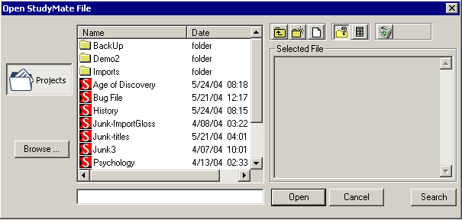

Highlight a StudyMate project by clicking it once. To obtain information on the project, select one of the two center buttons located above the “Selected File” window at right. The “Item List” button (right of center) is used to view a list of the items contained in the highlighted file. To preview a particular item, click the “Title.”

To open a highlighted file, click the [Open] button at the bottom of the window. (Double-clicking a file name will also open it.)

StudyMate allows projects to be organized within sub-folders. For example, you may want to organize StudyMate projects by class, course, or subject matter. To create a new folder, locate the toolbar above the “Selected File” window and click the “Create New Folder” button located second from left. To navigate down a level within a folder, double-click the folder itself. To navigate up a level, click the “Up One Level” button located leftmost on the row of buttons.

The [Search] button allows the text in a file to be searched prior to opening it (it can only be used if the “Item List” view is selected).

The [Browse…] button, located on the lower left side of the Open window, allows you to locate a StudyMate file (.rsf) that is located elsewhere on the hard drive and copy the file to the StudyMate Projects folder. It does not move the file or open it directly; rather, it creates a new “Projects” folder based on that file.

Opening and Converting a Respondus file
The Browse button can also be used to select and then convert a Respondus project file (.rsp) or a Respondus archive file (.rsa, .rpa) to StudyMate format. To do so, click [Browse...] and then change the pull-down list for “Files of Type” to “Respondus Files and Archives.” Upon selecting a Respondus project or archive file, various options will be offered regarding the conversion of the Respondus file to StudyMate format. Select the desired options and click [OK] to complete the conversion.

Note, the Import Wizard can also be used to convert a Respondus file to StudyMate format.

Downloading Publisher Test Banks
The [Download Test Bank] button is used to download publisher test banks that have been made available through the Respondus Test Bank Network (for more details, see http://www.respondus.com/testbank). To download a test bank, enter the File Code that has been supplied to you by the publisher. If applicable, also enter the password and any additional information that has been provided to you. StudyMate will then locate and download the test bank file. Since the file being downloaded is in Respondus format, it will need to be converted to StudyMate format. Following the download step, StudyMate will display various options regarding the conversion of the file to StudyMate format. Select the desired options and click [OK] to complete the conversion.

Creating a File
From the Start menu, select the Create button to create a new file. You prompted to enter a File Name and Description (both are required), as well as Author and Keyword information (optional). Click [OK] to create the file. You are now ready to add items to the file, using either the Edit menu or the Import Wizard.

Import Wizard
StudyMate allows the importing of No Answer, Single Answer, and Multiple Choice items. Although a StudyMate file itself can contain a mix of these three types, a file being imported by StudyMate must contain only one type of item at a time. To import more than one type of item to a StudyMate file, repeat the importing step for each type.

The text being imported must be formatted according to the guidelines discussed later in this section. Once the text is in the proper formatting, the Import Wizard will guide you through the importing process, as discussed here.

Step 1
Start the Import Wizard and select the file format being imported:

* MS Word (.doc), Rich Text (.rtf), Text (.txt)
* IMS QTI (.xml)
* Respondus (.rsp) or Respondus Archive (.rsa, .rpa)

IMS Question & Test Interoperability (IMS QTI) is a XML standard that is supported by various e-learning systems (for more information, see http://www.imsglobal.org/question/ ). If an IMS QTI file is being imported, StudyMate will use only the multiple choice and true/false questions, filtering out the rest.

Respondus is a separate authoring tool by Respondus Inc. that allows you to create assessment content for use with the leading course management systems (for more information, see http://www.respondus.com).

Step 2
If you are importing a Respondus or IMS QTI file, skip to the instructions provided in Step 3. If you are importing a MS Word, Rich Text, or Text file, the next screen in the wizard will ask whether the text being imported is formatted for Multiple Choice, One Answer, or No Answer items.

The next screen will remind you that the text formatting for Multiple Choice, One Answer, and No Answer items must follow the guidelines for the Standard Format, as discussed later in this section.

Step 3
The final screen of the wizard requires several actions. Click “Browse” to locate and select the file being imported.

Next, indicate whether the items being imported should be appended to the currently open file or whether an entirely new StudyMate file should be created. If the second option is selected, you will additionally need to enter the name of the file being created.

Each item being imported is given a “title.” If titles aren’t specified in the file being imported, StudyMate will create a title using the first 20 characters of the item wording. Alternatively, it is possible to specify “stem” text (ie., a prefix) that will then be followed by consecutive numbering starting with 001. For example, if you select the “Use stem...” checkbox and enter the text “Chapter1-” the title for the first item being imported will be Chapter1-001, the title for the second item will be Chapter1-002, and so on. (You do not have to enter stem text--this feature is entirely optional.)

Click the [Preview] button to preview the file being imported and to see if there are any warning messages. If warning messages are shown at the bottom of the screen, you need to decide whether to make changes to the file being imported or whether to continue without making changes. Be aware that some warning messages don’t actually require that changes be made to the file being imported. For instance, StudyMate will generate a warning message if two items being imported have the same title (StudyMate will automatically place the number “2” at the end of the second title to make it distinct from the first). In this example, if you don’t care that StudyMate is making a minor change to the title, ignore the warning message.

If you are satisfied with how the results look in Preview, click [Finish] to complete the import. The StudyMate file has is now created or appended. Switch to the Edit menu to further modify the file, or go to the Preview task to view the items.

Format Requirements for Importing “Multiple Choice” Files
StudyMate can import multiple choice questions from a MS Word document (.doc), a rich-text file (.rtf), or a text file (.txt). The .doc and .rtf files cannot contain images or embedded objects, such as tables. (If a StudyMate warning indicates that the document being imported contains images or embedded objects, the easiest way to strip these items is to save the file to .txt format.)

Multiple Choice items must be organized in the “Standard Format” before it can be imported. The Standard Format for multiple choice questions has required elements and optional elements, each of which is described next.

“Standard Format” for Multiple Choice Imports: Required Elements
Each question must begin with a question number, followed by either a period “.” or a parentheses “)”.

Example: 3)
Example: 3.

The question wording must follow the question number. (Note: at least one space should be between the question number and the question wording.)

Example: 3) Who determined the exact speed of light?
Example: 3. Who determined the exact speed of light?

Each answer must begin with a letter (A-J) followed by a period “.” or a parentheses “)”.

Example: 3) Who determined the exact speed of light?

a. Albert Einstein
b. Albert Michelson
c. Thomas Edison
d. Guglielmo Marconi

“Standard Format” for Multiple Choice Imports: Optional Elements
A Title can be imported with each multiple choice question. If a title is not provided for a question, the first set of characters of the question wording will be used as the question title in StudyMate. Titles must be placed at the beginning of a question and begin with “Title:” followed by the actual text for the title. If the title exceeds 20 characters, the remaining characters will be dropped during the import.

Example: Title: Speed of Light
3) Who determined the exact speed of light?

a. Albert Einstein
b. Albert Michelson
c. Thomas Edison
d. Guglielmo Marconi

The correct answer for a multiple choice question can be indicated in two ways. First, you may place an asterisk (*) directly in front of the answer choice (do not put a space between the asterisk and the answer choice).

Example: Title: Speed of Light
3) Who determined the exact speed of light?

a. Albert Einstein
*b) Albert Michelson
c) Thomas Edison
d. Guglielmo Marconi

The second option is to place a list of correct answers at the end of the file. The list must begin with the word “Answers:” and must be positioned at the end of the file.

Example: Answers:
1. A
2. C
3. B

Note that only letters “A-J” should be used to indicate a correct answer since StudyMate activities only support a maximum of 10 answer choices per question. Also note that any text that appears after the answer list will be ignored.

If neither of the above methods is used to specify a correct answer, StudyMate will automatically select the letter “A” as the correct answer. You will be warned if a question does not have a correct answer specified for it prior to completing the import.

Answer “Feedback” can be imported with multiple choice questions by placing the feedback immediately after the question wording and beginning the line with the @ symbol. (Note: There must be at least one space between the @ symbol and the feedback text.)

Example: Title: Speed of Light
3) Who determined the exact speed of light?

@ Albert Michelson was the first American to win the Nobel Prize in Physics (1907) for his measurements of the speed of light. His experiments laid the groundwork for Einstein’s Theory of Relativity.

a. Albert Einstein
*b) Albert Michelson
c) Thomas Edison
d. Guglielmo Marconi

The “Topic” and “Difficulty” level of Multiple Choice questions can also be specified in a file prior to the import. This is explained below in the section “Importing a Topic or a Difficulty Level.”

Format Requirements for Importing “One Answer” Items
At the start of the Import Wizard, indicate that you are importing a .doc/.rtf/.txt file and on the next screen select the “One Answer” option. Prior to selecting the file in the next step, make sure the text is formatted according to one of the two formats supported by StudyMate: a “standard format” as described next or in WebCT’s glossary format.

“Standard Format” for One Answer Imports
Standard Format syntax for One Answer items is as follows:

<term1>
<definition1>
<blank line1>
<blank line 2>
<term2>
<definition2>

This translates into the following example:

Albert Michelson
Determined the exact speed of light

Albert Einstein
Developed the General Theory of Relativity

It’s important that at least two blank lines appear after each item. That’s because a single blank line indicates a new paragraph for the same item, not a new item altogether. Also note that enhanced formatting such as bold and italics will be retained by StudyMate when items are imported from a .rtf or .doc file. However, StudyMate will prevent you from importing files that contain images or embedded objects, such as tables. (If StudyMate warns you that the document being imported contains images or embedded objects, it may be easier to export the file to .txt format so that these objects are automatically converted to a suitable format, or dropped altogether.)

The “Topic” and “Difficulty” level of One Answer items can be specified in a file prior to importing. This is explained below in the section “Importing a Topic or a Difficulty Level.”

Importing WebCT Glossary Files
WebCT, a popular course management system, has a glossary tool that can export items in .txt format. These files can be imported by StudyMate as One Answer items. The formatting is relatively simple:

: <term>
<definition>

Here’s a specific example:

:Albert Michelson
Determined the exact speed of light

:Albert Einstein
Developed the General Theory of Relativity

Note that only one blank line is required between items for this format, unlike the “Standard Format” described previously.

Format Requirements for Importing “No Answer” Items
A No Answer item is essentially a fact or brief text that has no answer associated with it.
StudyMate can import No Answer items from a MS Word document (.doc), a rich-text file (.rtf), or a text file (.txt). However, the file must first be organized in the “Standard Format,” which is actually quite simple:

<fact1>
<blank line1>
<blank line 2>
<fact2>

This translates into the following example:

Albert Michelson determined the exact speed of light

Albert Einstein developed the General Theory of Relativity

It’s important to remember that this formatting requires at least two blank lines between each item. That’s because a single blank line indicates a new paragraph for the same item, not a new item altogether. Also note that enhanced formatting such as bold and italics will be retained by StudyMate when items are imported from a .rtf or .doc file. However, StudyMate will prevent you from importing files that contain images or embedded objects. (If StudyMate warns you that the document being imported contains images or embedded objects, it may be easier to export the file to .txt format so that these objects are automatically converted to a suitable format, or dropped altogether.)

The “Topic” and “Difficulty” level of No Answer items can be specified in a file prior to importing. This is explained below in the section “Importing a Topic or a Difficulty Level.”

Importing a ‘Topic’ or a ‘Difficulty’ Level
The “Topic” and “Difficulty” level of a Multiple Choice, One Answer, or No Answer item can be specified in a file prior to importing it. To assign a topic to multiple items in a file, place the following tags before and after the items, respectively:

TOPIC: <enter topic name here>
TOPICEND:

For example, to place the following two questions into a topic called “Scientists” the following formatting would be used:

TOPIC: Scientists

3) Who determined the exact speed of light?
a. Albert Einstein
*b. Albert Michelson

4) Who formulated the General Theory of Relativity?
*a. Albert Einstein
b. Albert Michaelson

TOPICEND:

If you prefer to designate a topic for each item being imported, it isn’t necessary to include the “TOPICEND:” tag after each question. For example, the following formatting is acceptable where a different topic is being assigned to both items:

TOPIC: Michelson

3) Who determined the exact speed of light?
a. Albert Einstein
*b. Albert Michelson

TOPIC: Einstein

4) Who formulated the General Theory of Relativity?
*a. Albert Einstein
b. Albert Michaelson

TOPICEND:

Just remember to include a “TOPICEND:” tag any time you don’t want the topic to be attributed to subsequent questions or items.

A similar approach can be used to designate a 1-5 difficulty level (1=low, 5=high) for items being imported.

DIFFICULTY: <enter a number between 1 and 5>
DIFFICULTYEND:

For example, to assign the difficulty level of two questions to “3” the following formatting would be used:

DIFFICULTY: 3

3) Who determined the exact speed of light?
a. Albert Einstein
*b. Albert Michelson

4) Who formulated the General Theory of Relativity?
*a. Albert Einstein
b. Albert Michaelson

DIFFICULTYEND:

If you prefer to designate a difficulty level for each item being imported, it isn’t necessary to include the “DIFFICULTYEND:” tag after each question. For example, the following formatting is acceptable where a different difficulty level is being assigned to both items:

DIFFICULTY: 5

3) Who determined the exact speed of light?
a. Albert Einstein
*b. Albert Michelson

DIFFICULTY: 3

4) Who formulated the General Theory of Relativity?
*a. Albert Einstein
b. Albert Michaelson

DIFFICULTYEND:

However, remember to include a “DIFFICULTYEND:” tag any time you don’t want the difficulty level to be attributed to subsequent questions or items.

One final note about the Topic and Difficulty tags. If you are importing a WebCT glossary file, only one topic and/or difficulty level can be specified in the file. In addition, the first tag must appear at the top of the text file.

Quick Copy Wizard
The Quick Copy Wizard is the easiest way to select and copy items from two or more StudyMate files. To begin, select the Quick Copy Wizard button from the Start menu. The first page of the wizard provides the option of creating a new file or opening an existing StudyMate file and then copying items to it. Make your selection and click [Next]. If you selected the option to create a new file, provide a name and description of the file. If you selected the option to use an existing file, open the desired file as prompted. Click [Next] to continue.

The next page of the wizard prompts you to select the StudyMate files from which the questions will be copied. Highlight a file and click the [Select] button. Repeat this process until all files from which you want to select questions are selected. Click [Next] to continue.

The next page of the wizard prompts you to select a source file from the previous step. If the selected file has items that have been assigned to “topics,” the list can be further filtered by selecting a topic from the “Show items by topic” list.

You then have the choice of using Automatic Selection or Manual Selection. When Automatic Selection is chosen, the available number of questions for each type of item is displayed in the “Available to Select” column. In the next column, enter the number of questions to be selected for each type of item. When all entries are finished, click either the [Add to End of List] button or the [Insert Into List] button. Repeat this process for each of the source files.

The Manual Selection option allows the items for each file to be viewed before making a selection. In fact, you can preview individual items by clicking the title or by searching the entire list of questions using the [Keyword Search] option at top right. To select questions from this list, simply click the narrow column furthest to the left--a mark will appear next to the question. When finished with the selections, click either the [Add to End of List] button or the [Insert Into List] button. Repeat this process for each source file.

Note that the Automatic Selection and Manual Selection options may be combined. A file can also be reselected from the pull-down list and have additional items chosen from it. StudyMate will prevent you from selecting an item more than once.

Once items have been added to the list at the bottom of the screen, the Difficulty values can be edited manually. To delete an item from the bottom list, or to move it to a different location in the list, click the blue title and select the desired option. Finally, notice that a tally of the questions appears at the top right corner of the lower grid.

The next and final page of the wizard is self-explanatory. For example, to edit items in the file, select the option to go to the Edit menu. To preview the activities, select that option, and so on.

Click [Finish] to complete the wizard.

Editing a File
Overview of Edit Menu
Common Features Across all Item Types
Item Types and Activities
1) No Answer
- Fact Cards
- Fact Cards+
2) One Answer
- Flash Cards
- Pick A Letter
- Fill in the Blank
- Matching
- Crosswords
- Glossary
3) Multiple Choice
- Quiz
- Challenge
Adding Bold, Italics, Underline, and Super/Subscript
Web Links
Adding Images
Spell Check
Keyword Searches
Modifying, Rearranging, and Deleting Items
Using an Item as the Basis for a New Item
Copying Questions from Another StudyMate File

Overview of Edit Menu
The Edit menu in StudyMate allows new items to be added to a file or current items to be edited. Three types of items can be created: No Answer, One Answer, and Multiple Choice. Up to ten activities can be created from these items.

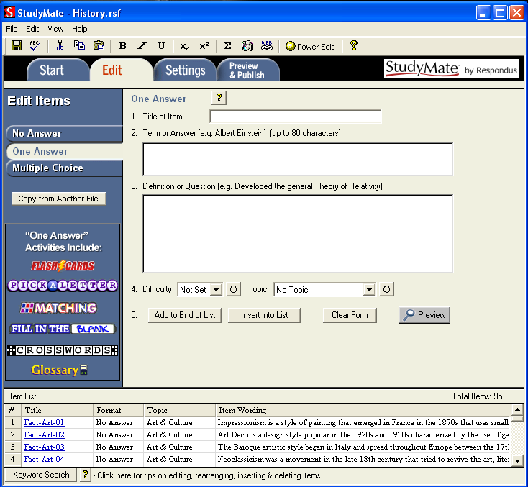

Common Features Across All Item Types
Three types of items can be created with StudyMate: No Answer, One Answer, and Multiple Choice. To create a new item, select the desired type from the left side of the screen. The entry form to its right will change accordingly; the Flash activities that can be generated from that type of item are also listed.

Each item allows the entry of a “Title.” A title can be up to 60 characters. If you do not enter a title, StudyMate will use the first 20 characters from the next data entry field.

Two optional features are available with each edit form: Difficulty level and Topic. The Difficulty level can be set between 1 and 5 (1=Low, 5=High). Items can also be assigned to a Topic, either an existing one or a newly created one. The small buttons located to the right of the Difficulty and Topic options determine whether an entry for that item is required. If the asterisk is selected, it becomes a required entry field.

Four buttons appear at the bottom of all edit forms. The [Add to End of List] button adds the current item to the end of the “Item List” (located at the bottom of the screen). Use [Insert Into List] to insert the current item to a specific position in the Item List.
The [Clear Form] button will erase all data that currently shows in the form. Finally, the [Preview] button opens a browser-like window that shows how the item will appear when exported as a Flash activity. The Preview window, which can be selected at any stage in the editing process, includes a pull-down list at top that allows a different activity or game to be previewed.

At the bottom of the Edit menu, the “Item List” displays the title, format, topic, and wording for each item in the file. The total number of items is shown at the top right of the list. By clicking the “title” of an item, a window containing the “properties” is displayed. It is here where you can modify, delete, or move the item, as well as use the selected item as the basis for an entirely new item. These features are discussed in the section “Modifying, Rearranging, and Deleting Items.”

Item Types and Activities
There are three types of items in StudyMate (No Answer, One Answer, and Multiple Choice). Several Flash-based games can be generated from each type of item. These are described below.

1) No Answer
Use a No Answer item to enter a fact, statement, or any text that doesn’t have a precise answer. The following fact is an example of a No Answer item:

Albert Michelson determined the speed of light in 1879.

The StudyMate activities that can be created with No Answer items include Fact Cards and Fact Cards+.

Fact Cards
Fact Cards are one-sided cards that display text on them.

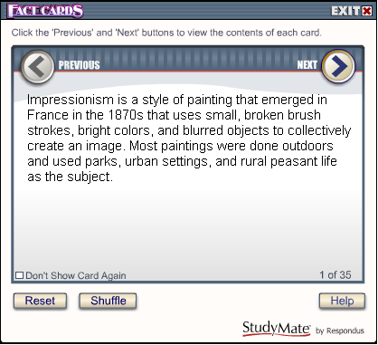

Click Next or Previous to scroll through the cards. Shuffle will randomize the deck of cards and Reset will return you to the first card in the deck.

Fact Cards+
Fact Cards+ is identical to Fact Cards except that it additionally sorts the cards into topics. The topics are then displayed along the left side of the Flash object. An item can be assigned to a topic during the editing or import steps.

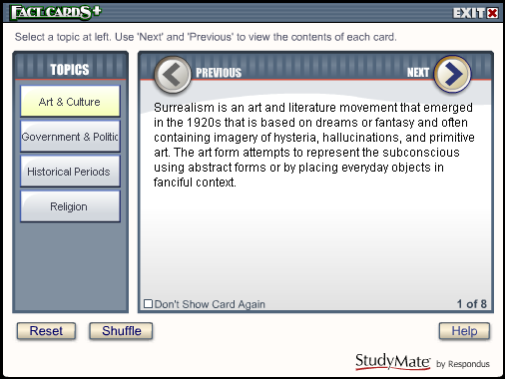

2) One Answer
A One Answer item has a word/phrase that is associated with another word/phrase. A common example is a glossary “term” that has an associated “definition.” Another example is a fill-in-the-blank “question” that has a specific word or phrase for the “answer.”

Example:

Term or Answer: Albert Einstein
Definition or Question: Developed the General Theory of Relativity

The StudyMate activities that can be created with One Answer items include Flash Cards, Pick a Letter, Fill in the Blank, Matching, Crosswords, and Glossary.

Flash Cards
Flash Cards are two-sided cards that display the term/answer on one side of the card and the definition/question on the second side of the card.

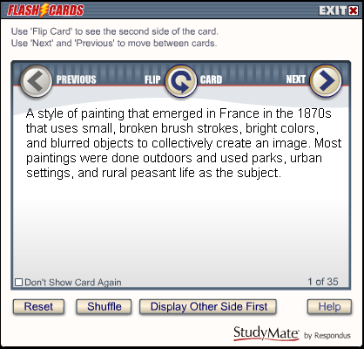

Click Flip Card to see the second side of the card. Select Next or Previous to scroll through the deck of cards. Shuffle randomizes the deck of cards and Reset returns you to the first card in the deck. The Display Other Side First option determines which side of the card is shown first.

Pick a Letter
Pick a Letter displays the definition/question at the top of the screen and has the user type or click the letters contained in the answer. If a letter appears more than once in an answer, all uses of that letter will be displayed when it is selected.

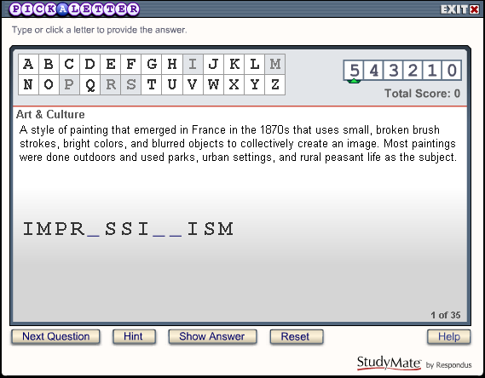

If an incorrect letter is entered, 1 point (of a possible 5 points) is deducted for that question. A user can continue answering the question even after the point value reaches zero.

Next Question proceeds to the next question in the list; no points are awarded if the answer isn’t completed before clicking Next Question. Hint reveals the next letter or character in the answer; one point is deducted for each hint until the point value for the item reaches zero. Show Answer reveals the entire answer; no points are awarded when this option is used. Reset starts the activity over again.

Once the final item is answered, a score will be displayed.

Fill In the Blank
Fill in the Blank displays the definition/question in the top section and has the user enter the exact term/definition for the answer. If the answer isn’t exactly correct, StudyMate provides a hint based on the text entered in the previous attempt. One point (of a possible 5 points) is deducted for each incorrect attempt. There is no limit to the number of attempts allowed, even if the point value for the item reaches 0.

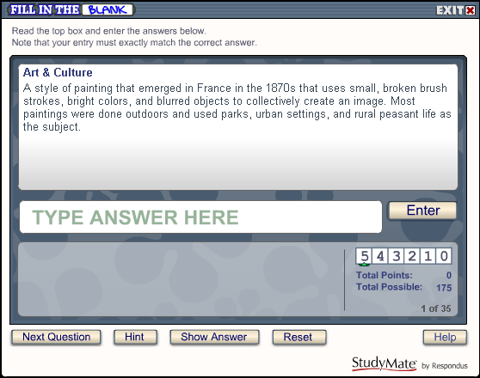

Next Question moves you to the next question in the list; no points are awarded if the answer isn’t completed before clicking Next Question. Hint reveals the next letter or number in the answer; one point is deducted for each hint until the point value for the item reaches zero. Show Answer reveals the complete answer; no points are awarded when this option is used. Reset starts the activity over again.

Once the final item has been answered, a score will be displayed.

Matching
The Matching activity displays the definition/question in the top section and has the user select from one of the nine term/answer windows below. The answer windows don’t change until six correct answers have been revealed. At that time the nine answer windows are repopulated and the sequence repeats itself.

It’s important to understand that the contents of the nine answer windows are randomly drawn from other items in the file. This works well if all One Answer items in the file are similar (eg. all items are persons, or all items are events, or all are definitions). However, if the One Answer items are a mixture of topics it may be desirable to exclude the Matching activity when generating Flash objects.

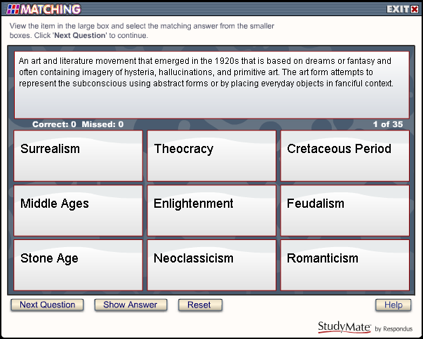

There must be at least 9 One Answer items in a file before StudyMate will allow the Matching activity to be exported to a Flash object.

Next Question moves you to the next question in the list; no points are awarded if the prior item isn’t answered before clicking Next Question. Show Answer reveals the answer for the item; no points are awarded when this option is used. Reset starts the activity over again.

Crosswords
A Crossword puzzle displays the “clue” (ie. the definition or question) at the bottom of the screen and requires the user to enter the “answer” in a corresponding, highlighted area of the grid. Answers are entered one letter at a time and it’s possible to switch to another clue before supplying any or all letters for the answer. Tallies for “correct” and “missed” letters are provided, with the possibility of multiple misses occurring for a single square.

Play begins by clicking a white, unanswered square. A highlight appears around all letter-boxes that comprise the answer, while the clue for the item is displayed at the bottom of the screen. The user can select a letter from the keyboard or from the palette of characters on the right side of the screen. International characters or numbers can be selected from the palette by first clicking the “>>>” button to reveal additional items. A puzzle is complete when all letter boxes have been solved.

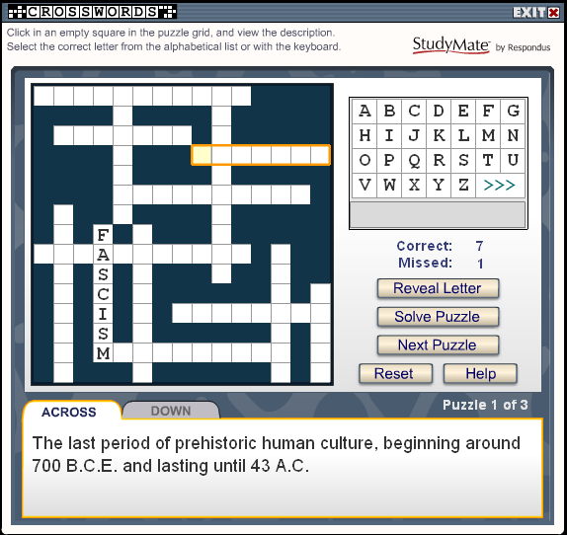

“Reveal Letter” displays the letter for the highlighted square and increases the “Missed” tally by one. “Solve Puzzle” reveals all remaining letters for the puzzle; no changes occur to the “Correct” or “Missed” tallies. The “Next Puzzle” button, when displayed, clears the current puzzle and skips to the next round (if one is available). The “Correct” or “Missed” tallies are unchanged when Next Puzzle is clicked.

“Reset” refreshes the screen, clears the tallies, and starts the first puzzle again. Puzzles are not recompiled when the Reset button is clicked, just started again.

If an answer has multiple words (“ICE AGE”), the blank space between words will be eliminated (“ICEAGE”). Special characters ($, %, #) and punctuation ( - ,?) are revealed at the start of a puzzle.

Puzzles are compiled in the StudyMate authoring tool, before they are exported to Flash format. Thus, a crossword puzzle will be the same each time a student uses it.

The Crosswords activity in StudyMate draws its data from the “One Answer” template. Only those terms/answers that have 15 or fewer characters will be used during the compilation of a puzzle. If the StudyMate file has more than about a dozen “One Answer” items, it can generate multiple puzzles (or “rounds”) from the available data. The Settings menu in the StudyMate authoring tool lets the instructor specify the maximum number of rounds permitted for a puzzle, ranging from 1 to 10.

The Settings menu also allows the instructor to control when crossword puzzles are compiled, which can take up to 4 seconds per puzzle round. The compilation time is dependent on how many “One Answer” items are contained in the file and how many puzzle rounds are being permitted (a Setting option). Another setting determines whether a puzzle is compiled each time the Preview task is selected in StudyMate or only if a change has been made to the StudyMate file.

Glossary
The Glossary tool provides an alphabetic listing of all One Answer items in the file. The term/answer is presented first, immediately followed by the definition/answer. Click a letter at the top of the screen to list the terms that start with that letter. The “other” category listed at the end of the alphabet will display terms that start with numbers, punctuation or special characters. The “All” option will list all One Answer items in the file alphabetically. To locate a glossary item that contains a particular word or phrase, use the Search feature.

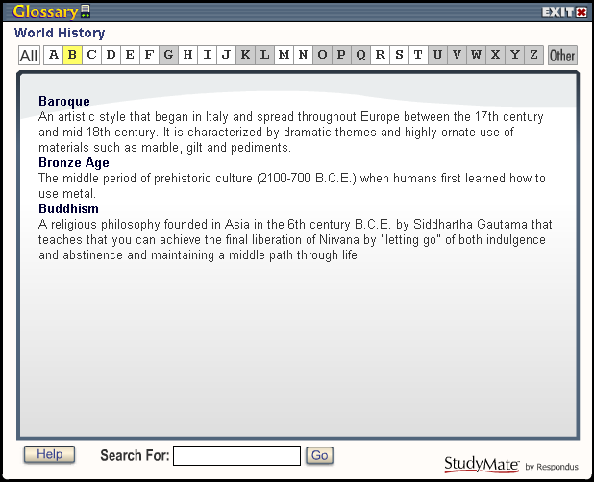

Note that it may be necessary to exclude the Glossary activity when generating Flash activities if the One Answer items don’t use a “term-definition” approach. For example, if the One Answer items are math problems in which the answer is a number, they won’t make a very useful glossary.

3) Multiple Choice
A Multiple Choice item displays a question, followed by a list with one correct answer and several distracters.

Example: 3) Who determined the exact speed of light?

a. Albert Einstein
b. Albert Michelson
c. Thomas Edison
d. Guglielmo Marconi

Answer “feedback” can be included with Multiple Choice questions so that students can view additional information about the answer. For example, the following feedback might be displayed after a student answers the above question (regardless of whether the correct or incorrect answer was submitted):

Albert Michelson was the first American to win the Nobel Prize in Physics (1907) for his measurements of the speed of light. His experiments laid the groundwork for Einstein’s Theory of Relativity.

To add feedback to a Multiple Choice question, click the [Feedback] button to open an editing window. When the feedback text has been entered, click the [X] at the top right corner of the feedback window to close it.

It’s possible to have the answer choices (distracters) displayed in random order for a question. Simply select the “randomize” box.

The following StudyMate activities can be created with Multiple Choice items: Quiz and Challenge.

Quiz
A Quiz will show one multiple choice question at a time. The question wording is presented at the top of the screen with the answer choices shown below it. The correct answer is selected by clicking on the letter that represents it.

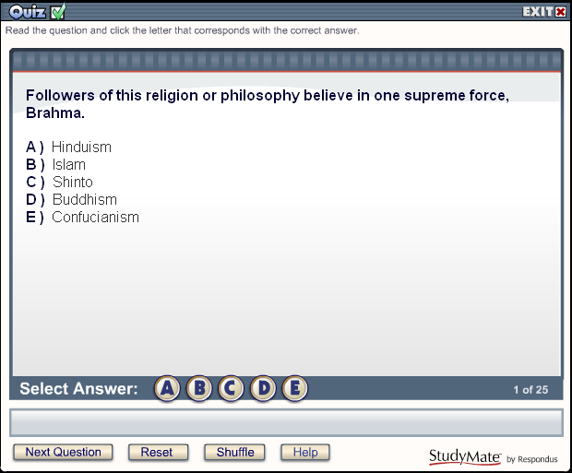

After an answer is selected, the “Next Question” button will flash and stay highlighted. If feedback is set to display immediately after a question is answered (see the “Settings” section below), the screen will indicate whether the answer is correct or wrong and will display any feedback entered for that question.

Reset starts the quiz again without any changes to the quiz itself. Shuffle also starts the quiz again but additionally randomizes and/or reselects the questions from a larger set of questions (again, depending on the “Settings” that have been selected).

Upon completion of the Quiz activity, a score will be presented. The user will have a chance to review the incorrectly answered questions at this point.

Challenge
Challenge presents multiple choice questions in a fun, game-show environment. The game board consists of 5 topics, where each topic has 5 questions with point values that range from 100 to 500.

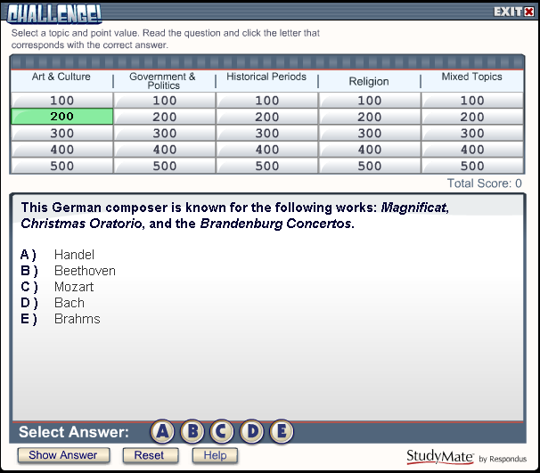

At the start of the Challenge game, select the “One Player” or “Two Player” option. The Two Player mode additionally allows names to be entered for the players or teams.

The game is started by clicking one of the point values below a topic. The question and answer choices are listed in the box below. The correct answer is selected by clicking on the letter that represents it. Players are immediately shown whether the answer is correct or wrong. If the answer selection is wrong, the correct answer will be displayed in green text and the incorrect answer will appear in red. If feedback is available for the question, it too will be displayed at this time.

Challenge makes use of the “Difficulty” option that is available when multiple choice questions are created or imported with StudyMate. Questions will be distributed within a topic according to its original difficulty weighting (1=low, 5=high). Questions that don’t have a difficulty level assigned to it are treated as a “3” in terms of difficulty. If there aren’t enough questions within the various levels of difficulty, StudyMate will distribute the questions the best that it can.

Challenge also uses the “Topics” option that is available when questions are created or imported with StudyMate. Questions that haven’t been assigned to a topic will be displayed under a “Mixed Topics” heading during the Challenge game.

The point value indicated when a question is selected will be applied to the player’s total score for the game. If the player answers the question correctly, the “total score” will increase by that amount. Conversely, if the answer is answered incorrectly, the score will be reduced by that amount. Negative scores are very much possible!

Show Answer will immediately display the correct answer to the question. Only 100 points are deducted if the Show Answer option is used. Thus, a “wild guess” may not be the best strategy when playing against another partner or team since the penalty for using Show Answer may be less.

Adding Bold, Italics, Underline, and Super/Subscript
StudyMate makes it possible to add bold, italic, and underline to words. Simply highlight the text you want to modify and click the appropriate [B], [I], or [U] button on the tool bar. The text will immediately change to the selected formatting. The superscript [X²] and subscript [X₂] tools function in the same manner. To remove the formatting, highlight the text again and reselect the corresponding button from the toolbar.

Web Links
The Web Links tool on the toolbar lets you add a link to a website or to a file that is located on another web server. A new browser window will open when the user clicks on the web link from within the Flash activity.

To create a web link, select the Web Link icon from the StudyMate toolbar and then follow the instructions for adding a web link. A link to a specific web page can be created, or you can create a link to a media file that resides on another server. In both cases, you will be prompted to enter the text that is to be displayed for the link itself.

A Web Link cannot be used if a text field already has advanced formatting, such as images, equations, tables, super/subscript. Similarly, if a text field has a Web Link, you’ll be prevented from adding advanced formatting, such as images and equations.

Adding Images
Images can be added to most text fields in StudyMate, but should be used sparingly because they can significantly increase the size of the Flash object.

From the Edit menu, position the cursor in the text field where you want the image to be added. Then click the “Insert image” icon on the toolbar, which is represented by a camera. A pop-up window will let you navigate to and select the image, provided that it is in one of these formats: bmp, gif, jpeg, png, pcx, and emf.

After selecting an image, the following window appears:

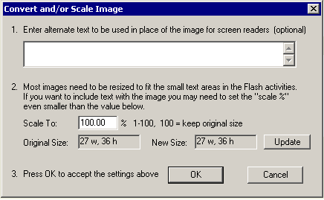

If the image is over 400 x 300 pixels, StudyMate will reduce it to the required size. An image can be made even smaller by manually adjusting the value for the “Scale to” field.

Alternate text for images can be entered in the field provided. Although alt text isn’t currently supported in the Flash objects exported by StudyMate, it is expected in a future release.

Click [OK] to close the window and return to the Edit menu. You will now see a set of green characters like <PIC_1> that represents the image. Be sure to preview all images prior to saving the item to the file. This will assure that the image size and position is as intended.

To delete an image, position the cursor in the same field where the item is located. Then click the “Insert Image” icon on the toolbar (the camera icon) and select the option to delete an existing image or file.

It’s important to understand that images can significantly increase the size of the final Flash object, particularly if high-color photos and images are used. A high-color image may be three times the size of a similar image that uses 256 colors. Also keep in mind that Flash objects work differently than HTML pages. Whereas an HTML page will begin displaying the content for a page while it loads the remaining elements, a Flash object must be fully downloaded before anything can be viewed.

If more than 10 images are contained in a StudyMate file, consider splitting the file into separate Flash objects. This will reduce the amount of time it takes for a student to download the object from a web server. The Preview task available from the “Preview & Publish” menu displays the overall size of the Flash object. This will help you determine whether a Flash object is becoming too large.

Equation Editor
The process of adding equations is similar to how images are added. From the Edit menu, position the cursor at the place in the text where the equation is wanted. Then click the “Equation Editor” button on the toolbar, which is represented by a summation symbol. The Equation Editor will open and you can begin creating the equation. The Equation Editor in Respondus works almost identically to the one that is available with Microsoft Word and WordPerfect. So if you’ve used those equation editors, you’ll already know how to use this one. A key thing to learn about the Equation Editor is that the top row consists of “symbols” while the bottom row consists of “palettes”. If you select a “symbol” from the top row, it’s no different than if you selected the + or = sign on your keyboard -- except that the symbols from the Equation Editor eventually get displayed as graphics. When a “palette” is selected from the bottom row, text can be entered at various insertion points. It’s also possible to select a palette from the bottom row, click in an insertion point, and then select a symbol from the top row. For more information about the Equation Editor, refer to the online help that is available from within the editor.

When finished editing the equation, exit the Equation Editor by either clicking the [X] that appears at the top right corner of the window or by selecting File from the menu bar and clicking Exit (do not simply minimize the Equation Editor). A new window appears that allows you to adjust the scaling of the equation. To accept the default setting of 150%, simply click [OK].

Alternate text for equation images can be entered in the field provided. Although alt text isn’t currently supported in the Flash objects exported by StudyMate, this feature is expected in a future release.

Once an equation has been added and you return to the Edit menu, you will see a set of green characters like <EQ_1> that represents the equation image. Be sure to preview all equations prior to saving the item to the file. This will assure that the image size and position is as intended.

To modify or delete an equation, position the cursor in the same field where the equation is located. Then click the Equation Editor icon on the toolbar and select the option to modify or delete an existing equation.

Using MathType with StudyMate
The Equation Editor in StudyMate is a special version of MathTypeTM by Design Science. If you frequently create documents with equations, you may find MathType is better suited to your needs. MathType is as easy to use as the Equation Editor and has many extra features to help you save time and create a wider range of equations.

MathType is available in English, Japanese, German and French. For further information about purchasing MathType, contact your software dealer or Design Science directly: Design Science, Inc., 4028 Broadway, Long Beach, CA 90803, USA.

Toll free: 800-827-0685 International: 562-433-0685
Fax: 562-433-6969
Email: sales@dessci.com
World Wide Web: http://www.dessci.com

If you already own MathType, you will need to reinstall it in order to have it work directly with StudyMate. MathType's readme file explains that it sets itself up to replace Equation Editor at the time that it's installed. So if you add a new application like StudyMate that uses the Equation Editor, you must re-install MathType.

Power Edit
The “Power Edit” task available from the Edit menu provides a table editor and a larger workspace for editing large blocks of text.

Click in the field that you want to edit and then click the “Power Edit” button on the toolbar. Most tasks on the Power Edit toolbar also appear on the main toolbar. Only the Table editor is unique.

Tables
StudyMate makes it possible to insert and edit simple tables. From the Edit menu in StudyMate, position the cursor at the location where you want to insert the table. Then click the “Power Edit” button and select the “Insert Table” icon from the toolbar. When the next pop-up window appears, specify the number of columns and rows that should be included in the table. Click the [OK] button to return to the Power Edit window. You can now click within the cells of the table and enter the text.

The width of the table cells can be adjusted by dragging the column lines. To edit other aspects of the table from the Power Edit menu, click within the table and select the desired action from the pull-down menu labeled “Table.” Use the “Insert” option to add a row or column to the table. Use the “Delete” option to delete a row or column, or to delete the entire table.

Finally, keep in mind that tables will eventually be turned into graphics so that they can be displayed in the Flash object. So use tables sparingly since they will increase the overall size of the Flash object.

Spell Check
The Spell Check feature, which is located on the toolbar for the Edit menu, will search the currently open file for spelling errors and allow corrections to be made. Once the Spell Check feature is started, it will search for words that do not match items stored in the dictionary. If the word is not found in the dictionary, you are given the option to “Change” the word to one that is suggested, to “Ignore” the identified word, to “Change All” such words in the file to one you select, or to “Add” the word to the dictionary. If you want to make more detailed changes to the question, click the “Edit This Question” button, which will close the spell checker and make the question available for editing.

Three dictionaries are included with a standard installation of StudyMate: American English, Canadian English, and British English. However, a free bundle of supplemental dictionaries can be downloaded from the Respondus website, including French, German, Spanish, Dutch, Finnish, and a comprehensive medical dictionary.

Keyword Searches
There are several places in StudyMate where the [Keyword Search] button appears, such as at the bottom of the Edit menu or when a file is being opened. This option allows you to search the currently open file or the file that is being previewed.

Up to three words can be included in a search. When more than one word is used, you can choose whether a match is required of all words or any of the words. The search can be further filtered by selecting a topic from the pull-down list (if the items have been assigned to a topic). A final option allows answer choices and feedback to be included in the search.

Modifying, Rearranging, and Deleting Items
It is easy to modify, move, or delete an item in StudyMate. From the Edit menu, select an item from the “Item List” by clicking on its “Title.” A window appears that displays the entire properties for the question. On the right side of the window are several options. Click [OK] to close the window, click [Delete] to delete the item, click [Preview] to preview the item, and click [Move] to place the item at a different position in the Item List. If you select the [Modify] button, you will be returned to the Edit screen and the current properties for that item will be displayed in the form--modify the item as you like. When modifying an item, notice that the two buttons at the bottom of the form now indicate “Save Changes” or “Cancel Changes”. If you want to save the changes to the item, select the corresponding button. If you don’t want the changes to be implemented, select [Cancel Changes].

Using an Item as the Basis for a New Item
To use an existing item as the starting point for a new item, locate the original item in the “Item List” at the bottom of the Edit menu. Select the item by clicking on the title. When the properties window appears, select the button [Use as Basis for New Item]. You will be returned to the Edit screen and the properties for the original item will be displayed in the form. The original title for the item will be modified slightly--for example, the number “2” will be added to the end of it. At this point you can rename the title and make any other changes you like. When finished, add or insert the item to the Item List.

Copying Items from Another StudyMate File
From the Edit menu it is possible to copy items from another StudyMate file. Click the button [Copy from another file] which is located on the left side of the screen. This will open a window containing the files stored in the default directory (\StudyMate Projects). Select a “source” file by double-clicking the file name or by clicking it once and selecting [Open].

Tip: Before selecting a file, you can search the contents of the file by clicking on it once and then clicking the [Search] button. You can also preview the items for a file -- prior to opening it -- by highlighting the file name and clicking the “Item List” button. Specific information for an item can be obtained by clicking its title.

Once the source file is selected, a new window lists the items contained in it. An item can be selected by clicking the column furthest to the left. A checkmark will indicate that the item has been selected. When all the desired items have been selected, choose either the [Add to End of List] button or the [Insert into List] button to add the items to the currently open file.

Settings Menu
Overview of Settings Menu
Settings for Item Types
HTML Templates (advanced feature)
- Creating HTML Templates
- Template Marker Fields
- Full Page Templates
- Append Templates
- Overriding CSS Styles

Overview of Settings Menu
The Settings Menu allows you to specify settings for each activity. There is a setting tab for the three item types (No Answer, One Answer, and Multiple Choice). The fourth settings tab allows you to control the design of the HTML file that is generated with the StudyMate Flash object during the publish step.

Settings for Item Types
Each StudyMate activity, except for Glossary and Challenge, has a setting that determines whether all items available for it will be displayed during each user session. The alternative is to display a subset of the available items during user sessions. For example, let’s say that the file contains 100 items that can be used with the “Pick A Letter” activity. Instead of including all 100 items each time the activity is played, you may prefer that 25 items be randomly selected each time. To do so, choose the “Select a fixed number” option and enter the number 25. (To clarify this example, all 100 items would be contained in the Flash object, but only 25 would be selected each time a student started the activity.) If you choose the option to have all items displayed during each user session, you have the choice of having the items delivered in random order or in the order that they appear in the StudyMate file.

Additional settings are available for the Quiz activity. To have feedback shown immediately after an answer is provided by the student, select the option “Show feedback after each question”. The “Show score after quiz” option is self-explanatory. The “Review missed questions” option will allow the student, upon completion of the quiz, to review each question that was missed.

Settings for Crosswords allow control of the number of puzzles (or “rounds”) included in a Flash object (ranging from 1-10). Another setting determines when puzzles are recompiled in the StudyMate authoring tool: each time the Preview task is started or only when a change has occurred to the StudyMate file.

Finally, note that the Matching activity requires a minimum of 9 items and that the Challenge activity requires a minimum of 10 items.

HTML Templates
During the “Publish” step, StudyMate generates an HTML file that provides the links used by students to launch the actual Flash game or activity. For example, students will click the HTML link “Challenge” to start the Challenge game.

The HTML Templates tab provides default HTML templates for each publishing option supported by StudyMate. “Full Page” templates are used when a Flash activity is being published to an entirely new HTML page. “Append” templates are used when a Flash activity is being appended to an existing HTML page. Most users will select a set of default templates and then never revisit this setting again. However, it is also possible to create custom HTML templates, as explained below.

Creating HTML Templates
StudyMate offers advanced users a way to create custom HTML templates and to specify which template(s) to use when creating Flash objects with StudyMate. This allows great control over the content and appearance of the HTML page or page section that is published along with the Flash file. To create a custom template, you must be very familiar with HTML coding. We don’t recommend that you try creating a custom template unless you have this type of technical knowledge. The remainder of this section provides a technical description of how to create templates.

As noted above, there are two types of StudyMate HTML templates: Full Page templates and Append templates. Full Page templates are used when publishing an entire HTML page, and must contain all the tags necessary for a complete HTML page. Append templates are used when appending to an existing HTML page, or replacing an existing activity. Append templates cannot contain certain tags associated with full pages. Both types of templates must contain a number of specific StudyMate marker fields that will be replaced during the publishing process with appropriate information.

Templates are stored as files with the extension .HTM or .HTML in a folder named templates in the StudyMate Projects directory (the default location is c:\StudyMate Projects\Templates). Templates can be added to this folder manually outside of StudyMate, or via the [Add Template...] button on the HTML Templates tab. Several sample templates are provided with the StudyMate installation.

All available templates are shown in the drop-down lists associated with each Course Management System or publishing option. In addition to any templates present in the templates folder, these lists also provide Default - Arial and Default - Times Roman selections. These default templates provide a simple page or section structure with sufficient information and hyperlinks but minimal clutter. They are identical to some of the sample templates provided with the installation.

When a template is selected in one of the drop-down lists, it will be immediately validated to determine whether it is suitable for its intended purpose. If new templates are added to the templates folder while the HTML Templates tab is displayed, the [Refresh Template Lists] button can be used to refresh the drop-down lists so that they reflect the newly-available templates.

Template Marker Fields
StudyMate HTML templates must contain a number of marker fields that are replaced with appropriate information during the publishing process. These fields are used when creating templates to represent where the associated information should be located in the published file. In the following partial example template, the marker field {STUDYMATE PageTitle} would be replaced with the activity title entered by the user in the Publish Wizard:

<html>
<body>
<title>{STUDYMATE PageTitle}</title>
...

The following is a complete list of the supported StudyMate marker fields and their descriptions:

Marker Field | Description | Usage
{STUDYMATE Script} | This field will be replaced with a JavaScript function that is used to launch the Flash object. This field also marks the location where StudyMate Organizer data is included when publishing to HTML + SWF. | Required for all templates
{STUDYMATE Title} | This field will be replaced with the activity title entered by the user in the Publish Wizard. | Required for all templates
{STUDYMATE Text} | This field will be replaced with the optional text or directions entered by the user in the Publish Wizard. If no such text was entered, this field will simply be removed from the published output. | Required for all templates
{STUDYMATE HorizontalLinks} | This field will be replaced with a set of hyperlinks to all the published activities, each separated by a non-breaking space. | Either a horizontal or vertical links field is required for all templates
{STUDYMATE VerticalLinks} | This field will be replaced with a set of hyperlinks to all the published activities, each separated by a line break. | Either a horizontal or vertical links field is required for all templates
{STUDYMATE ReplaceBegin} | This field will be replaced with a special StudyMate HTML comment that marks the beginning of the replaceable section in a Full Page template. | Required for Full Page templates; not allowed in Append templates
{STUDYMATE ReplaceEnd} | This field will be replaced with a special StudyMate HTML comment that marks the end of the replaceable section in a Full Page template. | Required for Full Page templates; not allowed in Append templates
{STUDYMATE PageTitle} | This field will be replaced with a string suitable for use as a page title. Currently this is the same value as published for the {STUDYMATE Title} field, but later the user may be able to specify the value for this field separately in the Publish Wizard. | Required for Full Page templates; not allowed in Append templates
{STUDYMATE StyleID} | This field will be replaced with a string suitable for use as a unique CSS style identifier within the HTML page. | Optional for all templates

Full Page Templates
Full Page templates are used when publishing to a new page in the Publish Wizard. They can contain any desired markup, provided they adhere to the following rules:

- They must contain <html> and </html> tags.
- They must contain <body> and </body> tags.
- They must contain the marker fields noted as “required” in the table above.
- The {STUDYMATE ReplaceBegin} field must come between the <body> and </body> tags in order to be recognized.
- The {STUDYMATE ReplaceEnd} field must come after a recognized {STUDYMATE ReplaceBegin} field in order to be recognized itself.
- With one exception, all other StudyMate marker fields must come between a recognized {STUDYMATE ReplaceBegin} field and a recognized {STUDYMATE ReplaceEnd} field in order to be recognized themselves.
- The one exception to rule #5 is that the {STUDYMATE PageTitle} field must not come between a recognized {STUDYMATE ReplaceBegin} field and a recognized {STUDYMATE ReplaceEnd} field in order to be recognized itself.

Full page templates must contain a replaceable section that is marked by the {STUDYMATE ReplaceBegin} and {STUDYMATE ReplaceEnd}marker fields. This replaceable section is the part of the template that will be replaced using an Append template when replacing an existing activity in the Publish Wizard. All other StudyMate marker fields except for {STUDYMATE PageTitle} must lie within this replaceable section.

Append Templates
Append templates are used when appending to an existing page or replacing an existing activity in the Publish Wizard. Instead of a full page of markup, they are a section of markup that will either be appended to an existing page, or will replace an existing section in an existing page. Append templates can contain any desired markup, provided they adhere to the following rules:

- They must not contain <html> and </html> tags.
- They must not contain <head> and </head> tags.
- They must not contain <title> and </title> tags.
- They must not contain <body> and </body> tags.
- They must contain the marker fields noted as “required” in the table above.
- They must not contain the marker fields noted as “not allowed” in the table above.

Overriding CSS Styles
Some Course Management Systems make use of Cascading Style Sheets (CSS) to control the look and feel of their HTML pages. In some cases, it may be desirable to override this behavior within a StudyMate HTML template in order to exert more control over the appearance of the published information.

This is the primary reason that the {STUDYMATE StyleID} marker field is supported. This field allows a template to specify a local CSS style block, associate that style block with a unique ID, then reference that style ID in the appropriate tag where it is desired to override existing CSS styles that may be in force.

For example, the following partial template shows how to format the activity hyperlinks published by StudyMate so that they are in a 10-point bold sans-serif font, regardless of what CSS settings may be in force at that point within the page after it is published to the Course Management System:

...
<style type="text/css">
<!--
div#{STUDYMATE StyleID} a
{
font-family: Arial,Verdana,Helvetica,sans-serif;
font-style: normal;
font-weight: bold;
font-size: 10pt;
}
-->
</style>
<div id="{STUDYMATE StyleID}">
{STUDYMATE VerticalLinks}
</div>
...

This technique is the same one used within the StudyMate sample and default templates to control hyperlink formatting in the presence of CSS. Regular formatting tags such as <font> and <bold> are also used in case the browser does not support CSS. The HTML comment around the contents of the <style> block is also necessary to prevent older browsers that do not support CSS from displaying the text within.

Preview & Publish Menu
Overview
Preview Task
Publish Wizard
- Publishing to Blackboard (6.0 or higher)
- Publishing to WebCT CE (4.0 or higher)
- Publishing to WebCT Vista (2.1 or higher)
- Exporting HTML+SWF files
- Exporting a SCORM package
Print Options

Overview
The Preview & Publish Menu contains two tasks: Preview and Publish Wizard. The Preview task is used to preview the complete Flash object, while the Publish Wizard is used to generate and output the Flash object.

Preview
The Preview task is similar to the preview option that appears in the Edit menu. The primary difference here is that all items in the file can be previewed, not just the item being edited.

Upon selecting the Preview option, a browser-like window will appear and will show what the Flash object will look like when it is published from StudyMate. An “Activity” list appears at the top of the window and allows you to change the preview to a different activity. Note that the Activity list only displays the activities that are available for the file currently open. For example, if the StudyMate file only contains Multiple Choice items, the Preview task will only list the Practice Quiz and Challenge activities. Likewise, if the file only contains One Answer items, it will exclude the Practice Quiz and Challenge activities from the Preview task.

During the preview, two options are available at the top right corner of the Flash object: “Mark for Delete” and “Edit this Item”. “Mark for Delete” creates a list of items to be deleted once the Flash object is closed (you’ll be asked to confirm the deletions at that time). “Edit this Item” will close the Preview task immediately and display the item in the StudyMate Edit menu.

The Flash object can be viewed with the Settings selections applied or without the Settings applied. In most situations you’ll want to see how the Settings (such as question randomization) affect the Flash object, but there are times when the original file order is preferred for previewing and editing purposes. Select the desired option before clicking the Preview button.

Publish Wizard
The Publish Wizard is available from the Preview & Publish menu and will guide you through the steps of publishing or exporting the final Flash object.

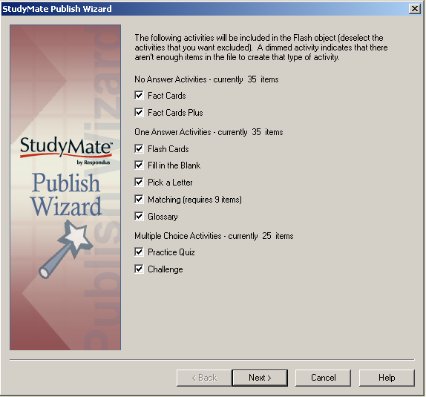

The first page of the wizard lists the activities and games that can be included with the Flash object that is being output. Deselect any activity that you want excluded from the Flash object. If an activity is dimmed, it means there aren’t enough items in the file for that activity. Click [Next] to continue.

StudyMate can publish Flash objects directly to Blackboard 6.0 or higher, WebCT CE 4.0 or higher, or WebCT Vista 3.0 or higher. If you plan to use the Flash object with a different web server or file server, select the HTML+SWF option instead. Click [Next} once a selection is made.

Publishing to Blackboard (6.0 or higher)
StudyMate can upload two formats of the Flash activities to a Blackboard 6 server. A “standard upload” results in a Flash (.swf) file and an HTML file to be uploaded to the specified area in Blackboard. A second option allows a SCORM package to be uploaded to the Blackboard course. In order to use the SCORM option, the Blackboard server must have the “Content Player” building block installed and SCORM must be enabled in the course settings. The main advantage to using SCORM packaging is that a student score for a “Quiz” activity can be passed back to the SCORM gradebook (only the score for the first quiz attempt is saved). A disadvantage is that you cannot edit the SCORM package once it’s been published to the Blackboard server. StudyMate is also unable to append to or replace a SCORM object once published to the server. (For more information on SCORM, see the section “Exporting SCORM Package.”)

The first time StudyMate is used to publish a Flash object to Blackboard (version 6.0 or higher), information must be entered about the Blackboard server and user account.

From the pull-down list labeled “Blackboard” select the “Add New Server” option.

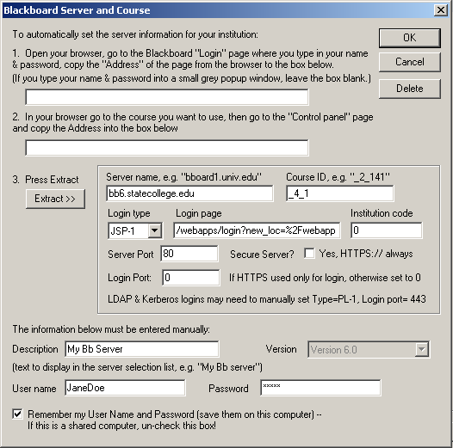

As instructed on the screen, the first step is to open a web browser and to go to the Login page for your Blackboard course. Be sure that you are at the actual page where you enter your user name and password, not a preliminary web page or portal. Copy the complete URL for this page and paste it in the field provided. (The easiest way to copy an URL that is displayed by a browser is to highlight it with your mouse, click the right mouse button, and select “copy”. Then go to the appropriate field in StudyMate, click the right button again and select “paste”.)

The second step requires you to log into your Blackboard course and select the “Control Panel” page. Again, copy the URL address displayed in the browser to the appropriate field in StudyMate. Upon clicking the “Extract” button, StudyMate will then fill in the Server Name and Course ID information needed to connect to the course.

The default “server port” is 80, but some institutions use a different port number for their Blackboard server. StudyMate generally detects the port number automatically during the extract step. But if it doesn’t, you can easily identify the correct port number by looking at the course URL. For example, the port number for the following Blackboard course is 8900: http://bb.statecollege.edu:8900/bin/common/course.pl?course_id=_31_1. (If no port number is shown in the URL, the setting should be left at 80.)

If your Blackboard system is installed on a "secure server" (https://), the appropriate checkbox should be selected. This checkbox should only be selected if the web browser address for your course begins with "https://" instead of the normal "http://" (note the "s").
Now provide a short description for the Blackboard server. You can call the server anything you want, such as “My Blackboard account”. If you access more than one Blackboard server, you will want to select a name that helps distinguish the two servers.

Enter your User Name and Password. This information should be entered exactly as you would if using a web browser to access your Blackboard course. If you want StudyMate to remember your User Name and Password for future sessions, select the “Remember my User Name...” checkbox.

Before clicking the [OK] button to activate the settings, be sure your Internet connection is live. If you use a dial-up service, you need to go ahead and connect to the Internet now.

Once all the server settings have been entered and you have a live connection to the Internet, click the [OK] button. StudyMate will then attempt to connect to your Blackboard server. The hour-glass in Windows will appear momentarily. If the connection is successful, StudyMate will display “Connected. Press Next.” As instructed, click the [Next] button.

If the connection to the Blackboard course is unsuccessful, an error message will indicate that StudyMate was unable to connect to the server using the provided settings. If this occurs, troubleshoot it as follows:

- Make sure you are running Blackboard 6.0 or higher

- Make sure your connection to the Internet is working properly.

- Double-check the Password and User ID information. In fact, open your browser, go to the Blackboard server that hosts your account, and enter the identical information. This will confirm that your Blackboard Server is up-and-running and that your User ID and Password are correct.

- Check the server port and secure server settings are correct

- Make sure you are running the latest version of StudyMate (go to Help>Check for Update to see if a more current version is available)

Once a successful connection has been made to the Blackboard server and you have continued to the next page of the wizard, you are prompted to select a course. Click the pull-down list labeled “Course” to view the list of courses. Then select the course to which you want to publish the Flash object. The Windows hourglass will again appear as StudyMate retrieves a list of the Content Areas contained in the course.

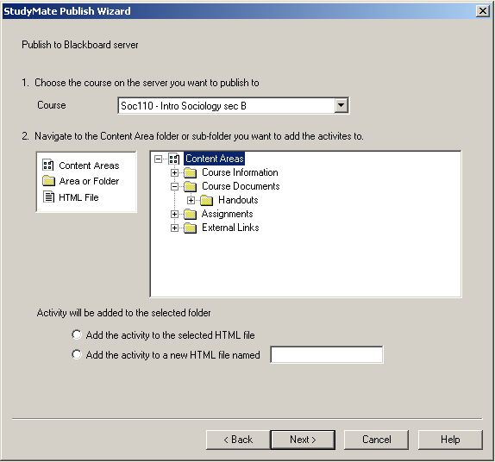

Now select a Content Area folder or sub-folder where the Flash object should be published. For instance, you might select the “Course Documents” folder or a sub-folder contained within it. If you are doing a “standard upload” (opposed to a SCORM package), the Flash object must be attached to an HTML page within the selected folder. So decide whether to append it to an existing HTML page or to create a new HTML page altogether. If you are creating a new HTML file, enter the name in the field provided. Then click [Next] to continue.

The options on the next page of the wizard are dependent on previous selections. If you are doing a “standard upload” and are having StudyMate create an entirely new HTML page, the option to “Add the StudyMate activity to the new file” is already selected. However, if you are appending the object to an existing HTML page, there are two options: 1) the Flash object can be placed at the bottom or top of the page or, 2) the Flash object can replace an existing StudyMate Flash object that was previously published.

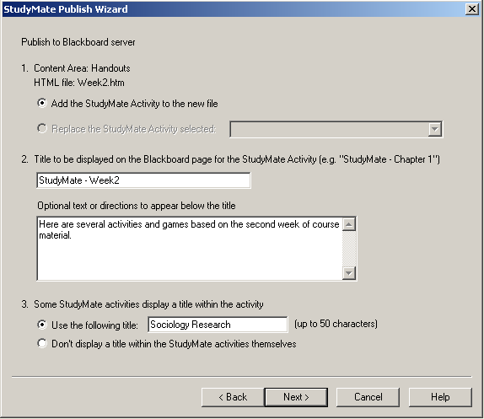

In the next section enter the title that should appear on the HTML page (the text will appear directly above the links to the Flash activities). Additional text, such as instructions to the student, can be added below the title.

In the following section, there is an option to provide a title that will appear in the Flash activities themselves. For example, the top row in the Challenge game can display a title such as “Psychology - Fall Competition!”

StudyMate has now gathered all the information needed to publish the StudyMate activities to the Blackboard course. Click [Next] to complete the publishing process.

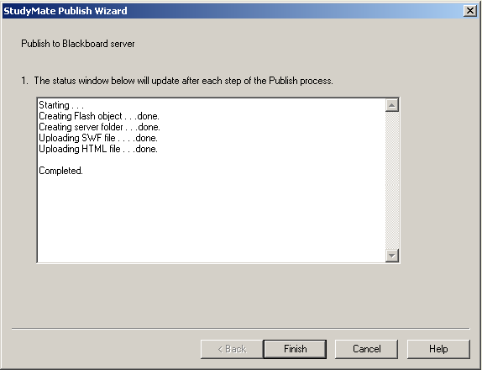

A status report is generated as StudyMate communicates with the Blackboard server. You will be told when the publishing step is complete. Then log into your Blackboard course and confirm that everything is published to your expectation.

Publishing to WebCT CE (4.0 or higher)
The first time that StudyMate is used to publish a Flash object to WebCT (version 4.0 or higher), information must be entered about the WebCT server and user account.

From the pull-down list labeled “WebCT Server” select the “Add New Server” option. The following window will appear:

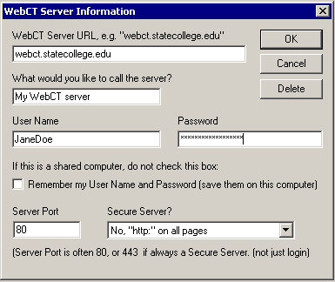

The first line asks for the URL of the WebCT server. The format for this entry should be similar to “webct.statecollege.edu”. Do NOT include a starting page or additional information such as “http://” in the URL.

For the next field provide a name for the server that was selected. You can call the server anything you want, such as “My WebCT account”. If you access more than one WebCT server, you will want to select a name that helps you distinguish between the two servers.

Now enter your User Name and Password. Enter this information exactly as you would if using a web browser to access your WebCT account.

If you want StudyMate to remember the User Name and Password for future sessions, select the “Remember my User Name...” checkbox. Don’t select this option if other people have access to the computer.

Now select the “server port”. Most servers use “80” as the server port, which is the default setting provided by StudyMate. However, if a different server port is being used, this can easily be determined by using a web browser to look at the URL for your WebCT course. If, for example, the URL contains a number at the end like “http://www.webct.statecollege.edu:8900”, then you would enter “8900” as your server port in StudyMate. If you have difficulty identifying your server port number, ask the WebCT administrator at your school for assistance.

Finally, if WebCT is installed on a "secure server" (https://), select the appropriate checkbox. The default option is for a standard “http://” server. The second option is for a WebCT server that is being entirely run on “https://”. A third option is used when a secure server is being used during the login process but not elsewhere in the WebCT course. Select the option that is appropriate for your WebCT server.

Before clicking [OK] to activate the settings, be sure your Internet connection is live. If you use a dial-up service, go ahead and connect to the Internet now.

Once the server settings have been entered and you have a live connection to the Internet, click [OK]. StudyMate will then attempt to connect to your WebCT server and the hour-glass will appear momentarily. If the connection is successful, the status window below the “WebCT Server” label will read “Connected. Press Next”. As instructed, click the [Next] button.

If the connection to the WebCT course is unsuccessful, an error message will indicate that StudyMate was unable to connect to the server using the provided settings. If this occurs, troubleshoot it as follows:

- Make sure you are running WebCT 4.0 or higher

- Make sure your connection to the Internet is working properly.

- Check that the URL for the server is correct (remember, don’t add extra information to this URL, such as start pages or “http://”).

- Double-check the Password and User ID information. In fact, open your browser, go to the WebCT server that hosts your account, and enter the identical information. This will confirm that your WebCT Server is up-and-running and that your User ID and Password are correct.

- Check the server port number (discussed above).

- Check that the correct “secure server” setting is selected

- Make sure you are running the latest version of StudyMate (go to Help>Check for Update to see if a more current version is available)

Once a successful connection has been made to the WebCT server and you have continued to the next page of the wizard, you’ll be prompted to select a course. Click the pull-down list labeled “Course” to view the list of courses. Then select the course to which you want to publish the Flash object. The Windows hourglass will again appear as StudyMate retrieves a list of the Organizer Pages, Content Modules, and HTML files contained in the course.

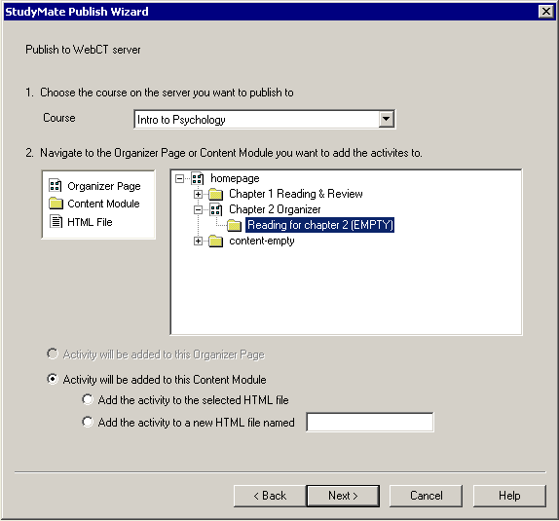

Now select the location in the course where the Flash object should be published. If the object is being published to a Content Module, it must be attached to an HTML page within the module. So decide whether you want to append it to an existing HTML page or whether you want to create an entirely new HTML page. If you are creating a new HTML file, enter the name in the field provided. Then click [Next] to continue.

The options on the next page of the wizard depend on what was selected in the previous step. If you are having StudyMate create an entirely new HTML page, the option to “Add the StudyMate activity to this page or file” is already selected. However, if you are appending the object to an existing HTML page, there are two options: 1) the Flash object can be placed at the bottom or top of the page, or, 2) the Flash object can replace an existing StudyMate Flash object that was previously published.

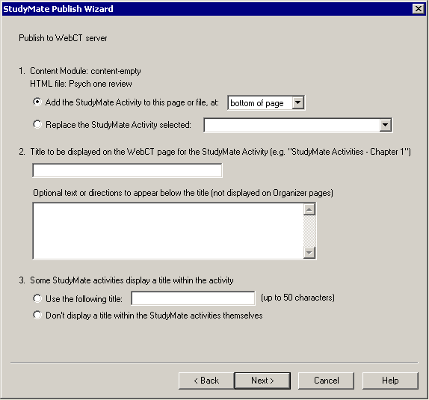

In the next section enter the title that should appear on the HTML page (the text will appear directly above the links to the Flash activities). Additional text, such as instructions to the student, can be added below the title.

In the third and final section, there is an option to provide a title that will appear in the Flash activities themselves. For example, the top row in the Challenge game can display a title such as “Psychology - Fall Competition!”

StudyMate has now gathered all the information needed to publish the StudyMate activities to the WebCT course. Click [Next] to complete the publishing process.

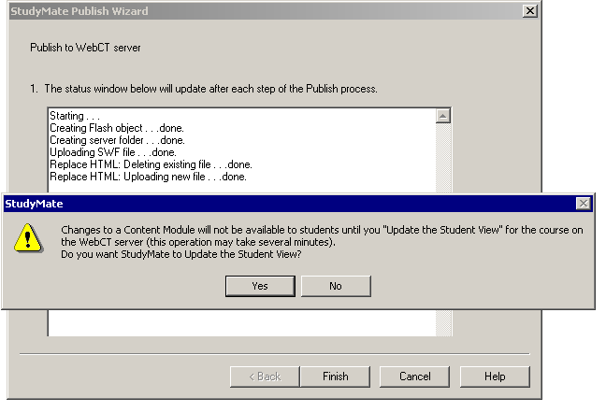

A status report is generated as StudyMate communicates with the WebCT server. If the Flash object is being published to a Content Module, a message will appear at the end of the publishing step that asks whether you want to update the Student View. (Even though a WebCT designer can immediately see the Flash object once it’s been published to the WebCT course, students won’t be able to see it until you have updated the Student View. We recommend that you answer “Yes” to this prompt.)

The publishing step is complete. Log into your WebCT course and confirm that everything is published to your expectation.

Publishing to WebCT Vista (2.1 or higher)
StudyMate can upload two formats of the Flash activities to a Vista server. A “standard upload” results in a Flash (.swf) file and an HTML file to be uploaded to the specified area in Vista. A second option allows a SCORM package to be uploaded to the Vista course or section. The main advantage to using SCORM packaging is that a student score for a “Quiz” activity can be passed back to the SCORM gradebook (only the score for the first quiz attempt is saved). A disadvantage is that you cannot edit the SCORM package once it’s been published to the Vista server. StudyMate is also unable to append to or replace a SCORM object once it is published to the server. (For more information on SCORM, see the section “Exporting SCORM Package.”)

The first time StudyMate is used to publish a Flash object to WebCT Vista (version 2.1 or higher), information must be entered about the Vista server and user account.

From the pull-down list labeled “Vista Server” select the “Add New Server” option. The following window will appear:

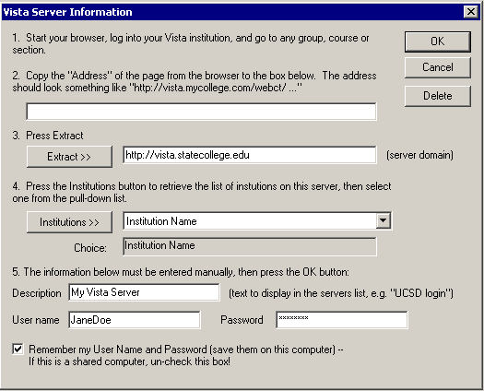

The first step requires you to start a web browser, log into your Vista course, and go to any group or section. For the second step, copy the complete URL for this page and paste it in the field provided. (The easiest way to copy the URL is to highlight it with your mouse, click the right mouse button, and select “copy”. Then go to the appropriate field in Respondus, click the right button again and select “paste”.)

Before proceeding with the third step, make sure your Internet connection is live. Then click the “Extract” button. For the fourth step, click the “Institutions” button and then choose your institution from the list that becomes available.

For the fifth step, enter whatever name you like for the description of the WebCT Vista server, such as “My Vista Server”. Also enter your designer-level User Name and Password exactly as you would if using a web browser to access your WebCT Vista courses. (Note, you must have a designer-level -- or higher -- account to publish exams to Vista. You cannot create exams in Vista using instructor-level, teaching assistant, or student accounts.)

Finally, if you want StudyMate to remember your User Name and Password for future sessions, select the “Remember my User Name...” checkbox.

Once all the server settings have been entered click [OK]. The window will close and StudyMate will indicate that it has successfully connected with the Vista server. Click [Next] to continue to the next page of the wizard.

StudyMate now looks up the Groups and Sections that are available to you and displays them in the drop-down list. Select the group or section to which the Flash object will be published. The Windows’ hourglass will again appear as Respondus determines whether additional templates are associated with the Group or Section that was selected. If more than one template is available, select the one to be used.

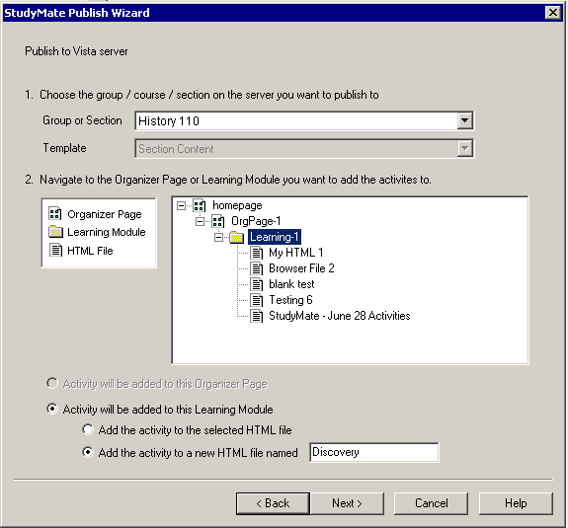

Now select the location in the course where the Flash object should be published, either an Organizer Page or a Learning Module. For a “standard upload,” the HTML/SWF files need to be attached to an HTML page if published to a Learning Module. So decide whether to append it to an existing HTML page or whether to have it create an entirely new HTML page. If you are creating a new HTML file, enter the name in the field provided. Then click [Next] to continue.

The options on the next page of the wizard are dependent on previous selections. If you are doing a standard upload of HTML/SWF files and are having StudyMate create an entirely new HTML page, the option to “Add the StudyMate activity to this page or file” is already selected. However, if you are appending the activities to an existing HTML page, there are two options: 1) the Flash object can be placed at the bottom or top of the page, or, 2) the Flash object can replace an existing StudyMate Flash object that was previously published. (These options won’t appear if publishing a SCORM package.)

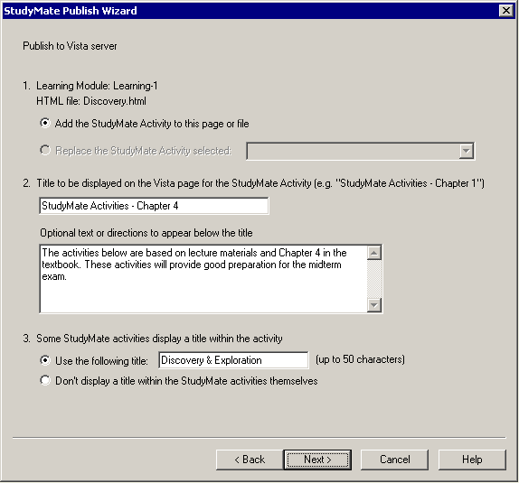

In the next section enter the title that should appear on the HTML page (the text will appear directly above the links for the Flash activities). Additional text, such as instructions to the student, can be added below the title.

In the following section there is an option to provide a title that will appear in the Flash activities themselves. For example, the top row in the Challenge game can display a title such as “Discovery & Exploration”.

StudyMate has now gathered all the information needed to publish the StudyMate activities to the Vista course. Click [Next] to complete the publishing process.

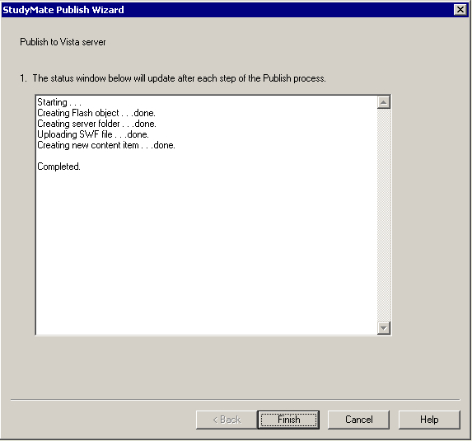

A status report is generated as StudyMate communicates with the Vista server. Once the publishing steps are complete, log into your Vista course and confirm that everything is published to your expectation.

Exporting HTML+SWF Files
If you want to export a StudyMate activity so that it can be added to a web page, you must use a bit of HTML code. StudyMate will provide the needed HTML code when the SWF is exported.

Start the StudyMate Publish Wizard and select the activities to be included with the Flash file. On the next page of the wizard select the “HTML+SWF” option and click [Next].

You are now prompted to enter the title that should appear on the HTML page (the title text will appear directly above the links to the Flash activities). Additional text, such as instructions to the student, can be added below the title.

In the next section, there is an option to provide a title that will appear in the Flash activities themselves. For example, the top row in the Challenge game can display a title such as “Psychology - Fall Competition!”

Finally, click the [Save As] button and browse to a location on your hard drive to where the Flash file and HTML file should be saved. Once a folder is selected, click [Finish] to complete the export process.

In order to view the exported StudyMate activities, you must open the HTML file that was exported, not the .swf file itself. (The browser needs the HTML code in order to properly start the Flash object.)

The final step is to upload the files to your web server. You can either upload both the HTML page and the SWF file to the same folder on the web server, or you can add the body of the HTML file to one of your own pages and upload only the SWF file (place it in the same folder).

Exporting a SCORM package
The Shareable Content Object Reference Module (SCORM) is an XML specification that enables the reuse and migration of web-based learning content in different environments and products. Many of the leading course management systems and learning management systems support SCORM, including WebCT Vista and Blackboard 6 (and higher).

The Publish Wizard in StudyMate includes a SCORM option within the “Blackboard 6” and “WebCT Vista” publishing options. It’s easier to use these integrated publishing options for SCORM, rather than the manual “SCORM Package” option that is required for use with other systems.

StudyMate supports the “grade” feature in SCORM, which allows a score to be passed from the Flash object to the e-learning system. At present, only the “Quiz” activity in StudyMate uses this feature (the score obtained during the first attempt of the Quiz is recorded). If the instructor wants to have the Quiz score saved, this option must be selected during the final step of the Publish Wizard.

StudyMate also supports the “time” feature which indicates how much time a student spent on each StudyMate activity. However, this is an optional feature in the SCORM specification and it isn’t supported by many e-learning systems.

Print Options
StudyMate allows you to questions and items or save them to MS Word format for further enhancement and printing. To begin, go to the Preview and Publish menu in StudyMate and select the Print Options tab.

The screen now displays the printing options available in StudyMate. The first step is to select the Formatting options that are desired, including the type and range of items to be included in the printout.

The second step allows you to specify the “header” information to appear at the top of pages, such as a person’s name, the file name, or the date.

In the final step, you can preview the file (formatted selections will be displayed), save the file to MS Word or rich-text format, or send the file directly to a printer.

Other Tools & Features
Overview
Preferences
Save As Copy
Check for Update
StudyMate Organizer

Overview
There are several additional tools in StudyMate that offer a range of functions. Each of these is discussed below.

Preferences
Preference settings can be accessed from the File menu bar. The first item allows you to move or rename the StudyMate Projects folder. If the folder is moved in Windows, it’s essential that the location be updated here.

The second item in preferences determines whether StudyMate will automatically check for product updates. The checking occurs every few weeks.

The next item allows you to enter or change the default author name for StudyMate project files.

The final two settings determine whether the answer choices for multiple choice questions will be randomized when questions are imported or created new. Note that changing this setting doesn’t affect questions that are already contained in the project, only new questions that are added to it.

Save As Copy
The Save As Copy tool, located on the File pull-down menu, can be used to create a copy of the currently open project file. After the project is saved, StudyMate will begin using the newly named project file.

If you plan to move a StudyMate project to another computer, and if the StudyMate project contains embedded objects such as equations or images, be sure to use the “zip” feature that’s available in Save as Copy (otherwise these objects will be missing when the file is opened on the other computer). With the Save as Copy window displayed, change the “Save as Type” pull-down list to “zip archive”. All files associated with the StudyMate project will be stored in the zip archive.

Item Title Tool
There are situations where it is desirable to rename all the titles in the StudyMate project file to provide a consistent look or numbering sequence. For example, if questions are copied or imported from a variety of sources the resulting titles may look inconsistent and haphazard.

The Item Title Tool, located under File on the menu bar, lets a “stem” (or prefix) be specified for item titles. Consecutive numbering will automatically be generated for the text that appears after the stem, beginning with 1 (or 01, or 001, etc.). For example, if you enter “Chapter1-” as the stem text, and then select “001” as the format for the numbering scheme, the title for the first item will be changed to Chapter1-001, the title for the second item will be changed to Chapter1-002, and so on. If a range is specified for the titles being changed, even more specific titles can be provided throughout the file. For instance, questions 1-20 might use the stem “Ch1-Unit1-” and questions 21-30 might use the stem “Ch1-Unit2-” and so forth.

Properties
Select properties from File on the menu bar to view or change the properties for the currently open file. There are three fields that can be edited: Author, File Description, and Keywords.

Check for Update
The “Check for Update” tool, located on the Help menu bar, provides an easy way to see if an update is available for StudyMate. Every few weeks, StudyMate will generate a message that asks whether it can check for an update. No information about your computer hardware and software is collected by Respondus, Inc. during this process. Instead, the StudyMate software retrieves information from Respondus.com and will display a message if an update is available. You will then have the choice of upgrading to the latest version of the software.

To manually check for a software update, select the “Check for Update” option from the Help pull-down menu (you will need a live Internet connection). StudyMate will instantly return a message indicating whether an upgrade is available. If an upgrade to StudyMate is available, you can let StudyMate download the required file(s) automatically and update the software for you. This is the easiest way to apply a patch or upgrade.

If you prefer that StudyMate does not periodically prompt you to check for an update, go to the File menu, select Preferences, and unselect the appropriate checkbox under the General tab.

StudyMate Organizer
StudyMate Organizer is a free application that makes it easy to organize, preview, and launch Flash (.swf) files on a Windows computer or local network. If you select the “HTML+SWF” option during the Publish Wizard, the final option will allow you to start StudyMate Organizer after the files are saved. If StudyMate Organizer isn’t already located in the folder to where the HTML+SWF files are saved, it will place a copy in that folder.

StudyMate and most other Flash authoring tools export a Flash file (.swf) and an HTML file that is used to launch the Flash object. If you launch the Flash object without using the HTML file, it will often display using an incorrect window size and without the setting information contained in the HTML file.

StudyMate Organizer is most useful when Flash files are being delivered to students on a local computer or network. It eliminates the need to have students locate the HTML file that corresponds to the Flash object (or to create separate shortcuts for each Flash activity).

StudyMate Organizer doesn’t require an installation program (it’s a single file named “StudyMateOrganizer.exe”) and the swf/html files must be located within the same folder as StudyMate Organizer or in a subordinate folder. Or to put it another way, StudyMate Organizer doesn’t let students browse to other locations in search of Flash objects, so be sure to place the intended .swf/html files in the same folder as StudyMate Organizer.

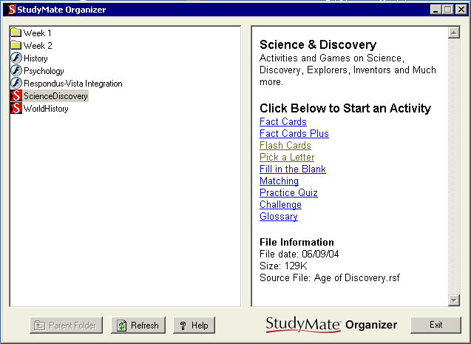

All pairs of swf/html files contained in the same folder as StudyMate Organizer will be listed in the left window as a single object. If the Flash object was created with StudyMate, highlight the file by clicking it. Additional information about the Flash object will then appear in the window at the right, including:

- Title of the Flash object
- Keywords that were entered by the author of the StudyMate activity
- Links for launching a particular StudyMate activity or game
- File Information (date, size, source file)

If the Flash object was created with a different authoring tool, less information will be displayed in the right window.

To launch a Flash activity, click on the link in the right window.

Disclaimer of Warranty
While Respondus, Inc. has tried to ensure the dependability of the software and documentation, it is provided "as is" without warranty of any kind. Agents of the supplier may have made statements about this software. Any such statements do not constitute warranties and shall not be relied on by individuals in deciding to use the program.

Because of the diversity of conditions and hardware under which this program may be used, no warranty of fitness for a particular purpose is offered. Test the program thoroughly before relying on it. You assume the entire risk of using the program. Respondus, Inc. shall not be liable for any expense, claim, liability, loss, or damage (including any incidental or consequential damage), loss of profits, loss of reputation, or any loss whatever direct or indirect, by you from either the use of or the inability to use the software.

Copyright, Ownership, and Use of Software
All software, with exception of the Equation Editor, remains the property of Respondus, Inc. The software and written materials are copyrighted. This license is not a sale of the original software or any copy. You own the physical media on which the software is originally or subsequently encoded, but Respondus Inc. retains title and ownership of the software on all media.

You are not permitted to install the executable code version of this product on a network server or virtual server. You may not customize the Product. Except as otherwise permitted by written consent, you may not: (i) modify or create any derivative works of the Product or documentation, including translation or localization; (ii) decompile, disassemble, reverse engineer, or otherwise attempt to derive the source code for the Product; (iii) redistribute, encumber, sell, rent, lease, sublicense, or otherwise transfer rights to the Product; or, (iv) remove or alter any trademark, logo, copyright or other proprietary notices, legends, symbols or labels in the Product.

© 2004 by Respondus, Inc. All Rights reserved. The Sentry Spelling-Checker Engine is copyrighted by Wintertree Software, Inc.

Respondus is a registered trademark of Respondus, Inc. Blackboard is a registered trademark of Blackboard, Inc. WebCT is a registered trademark of WebCT, Inc. eCollege is a service mark of eCollege. Macromedia and Macromedia Flash are registered trademarks of Macromedia. Microsoft, MS Word, Excel, and Windows are registered trademarks of Microsoft Corporation. All other trademarks are the property of their respective owners.

